Physical Science Study Book
Diagrams & Practice Questions — Student Edition
GED & HiSET Science · GRDM Publishing, LLC · gingertheteacher.com
Study the diagram, then circle the best answer for each question.
Name: _______________________________ Date: ______________

Matter & Its Properties
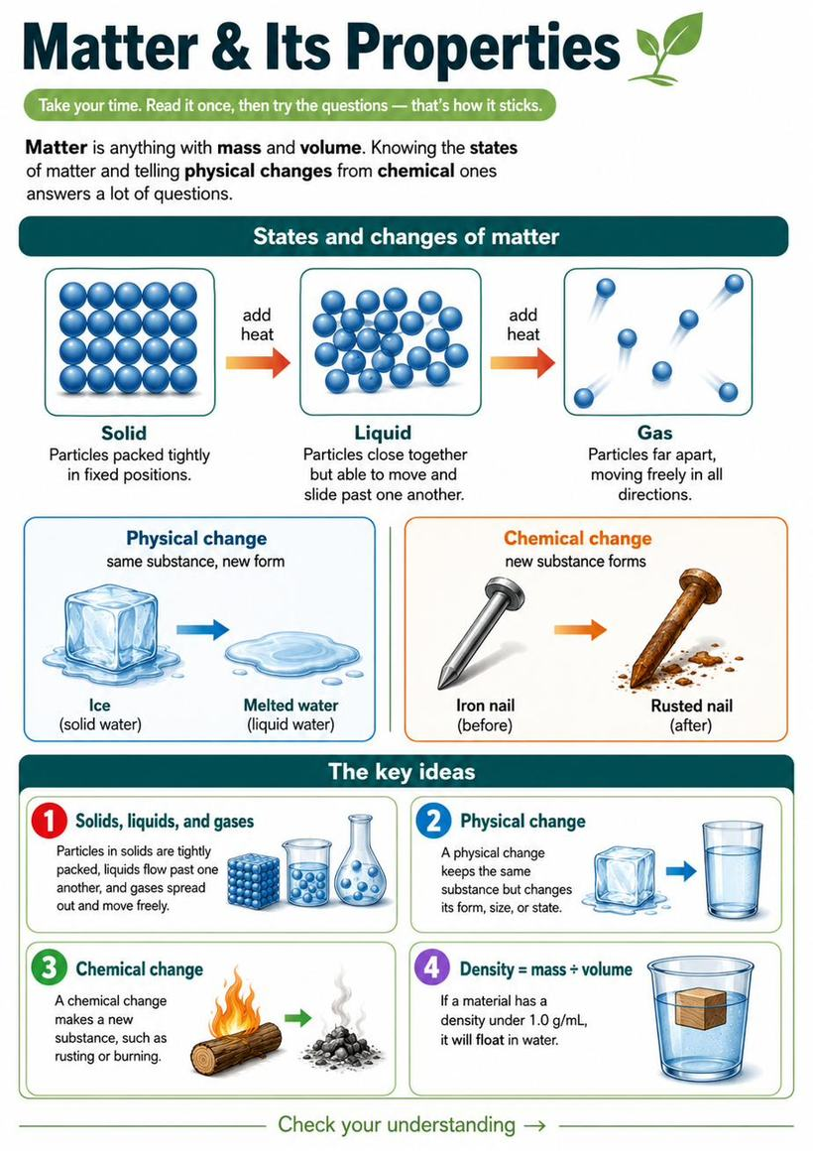
Questions
1. What is the main idea of this passage?
A. Ice is cold
B. The states of matter and the two kinds of changes
C. Gases are invisible
D. Iron rusts slowly
2. According to the passage, ice melting is an example of a:
A. Chemical change
B. Physical change
C. New substance forming
D. Gas
3. Which of the following is a chemical change?
A. Ice melting
B. Iron rusting
C. Water boiling
D. Tearing paper
4. Which material would sink in water?
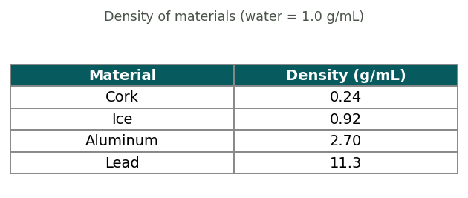
A. Cork
B. Ice
C. Aluminum
D. None

Atoms & Chemical Reactions
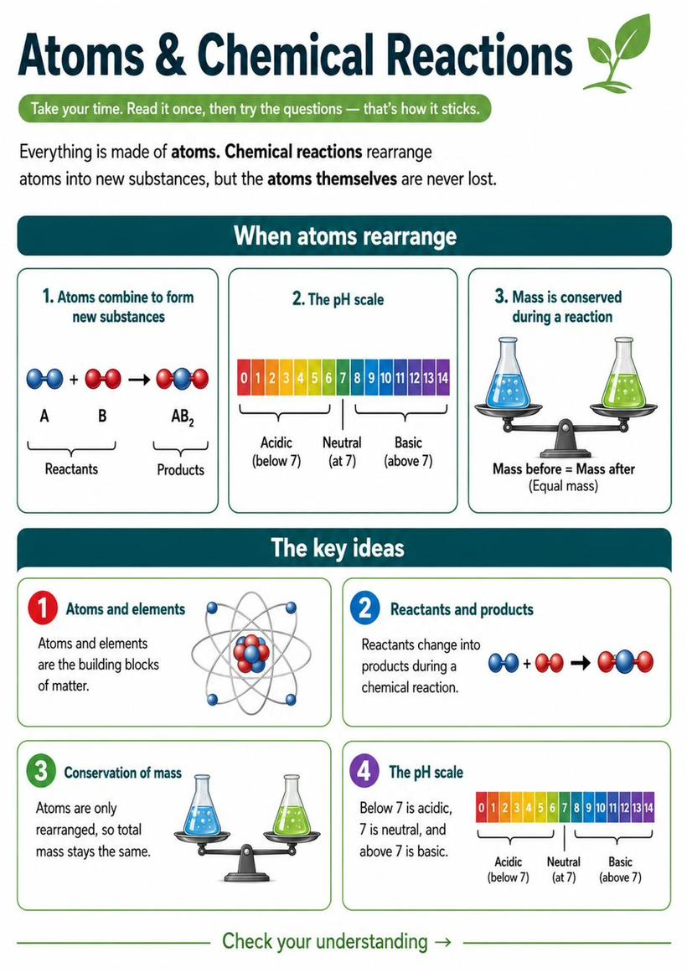
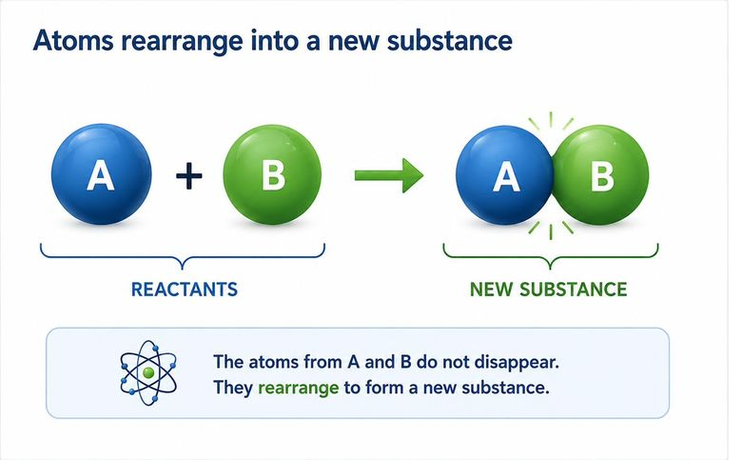
Questions
1. What is the main idea of this passage?
A. Water is a compound
B. Atoms build all matter, and mass is conserved in reactions
C. Gold is valuable
D. Reactions happen fast
2. In the passage, an 'element' is:
A. A mixture of substances
B. A substance made of just one kind of atom
C. A kind of reaction
D. A drop of water
3. In a sealed jar, 10 g of reactants react completely. What is the total mass of the products?
A. Less than 10 g
B. Exactly 10 g
C. More than 10 g
D. It cannot be known
4. A substance with a pH of 3 is:
A. A base
B. Neutral
C. An acid
D. A metal

Chemical Equations
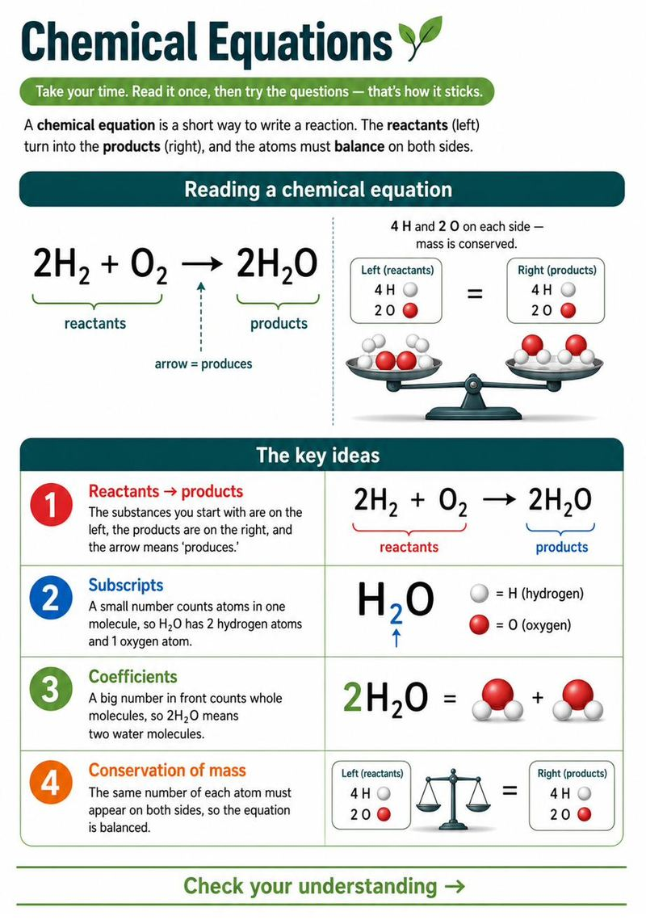
Questions
1. What is the main idea of this passage?
A. Arrows are important
B. How to read a chemical equation
C. Water is H₂O
D. Atoms are tiny
2. According to the passage, why must an equation be balanced?
A. To look neat
B. Because atoms are never created or destroyed
C. Because of the arrow
D. To use bigger numbers
3. In the equation 2H₂ + O₂ → 2H₂O, which are the reactants?
A. 2H₂O
B. 2H₂ and O₂
C. Only O₂
D. The arrow
4. What does the arrow (→) in a chemical equation mean?
A. Equals zero
B. 'Produces' or 'yields'
C. Subtract
D. Divide
5. In the formula H₂O, how many hydrogen atoms are there?
A. 1
B. 2
C. 3
D. 0
6. In 2H₂O, how many water molecules are shown?
A. 1
B. 2
C. 4
D. 6
7. Why must a chemical equation be balanced — the same atoms on both sides?
A. To look neat
B. Because atoms are never created or destroyed
C. To make the numbers bigger
D. Because of gravity
8. How many oxygen atoms are on the LEFT side of 2H₂ + O₂ → 2H₂O?
A. 1
B. 2
C. 4
D. 0
9. In C + O₂ → CO₂, how many oxygen atoms are on each side?
A. 1
B. 2
C. 3
D. 4
10. In the formula CH₄, how many hydrogen atoms are there?
A. 1
B. 2
C. 4
D. 6
11. In 2NaCl, how many chlorine (Cl) atoms are shown in all?
A. 1
B. 2
C. 3
D. 4
12. In CH₄ + 2O₂ → CO₂ + 2H₂O, which substance is a PRODUCT?
A. CH₄
B. O₂
C. CO₂
D. None of these

Forces & Motion
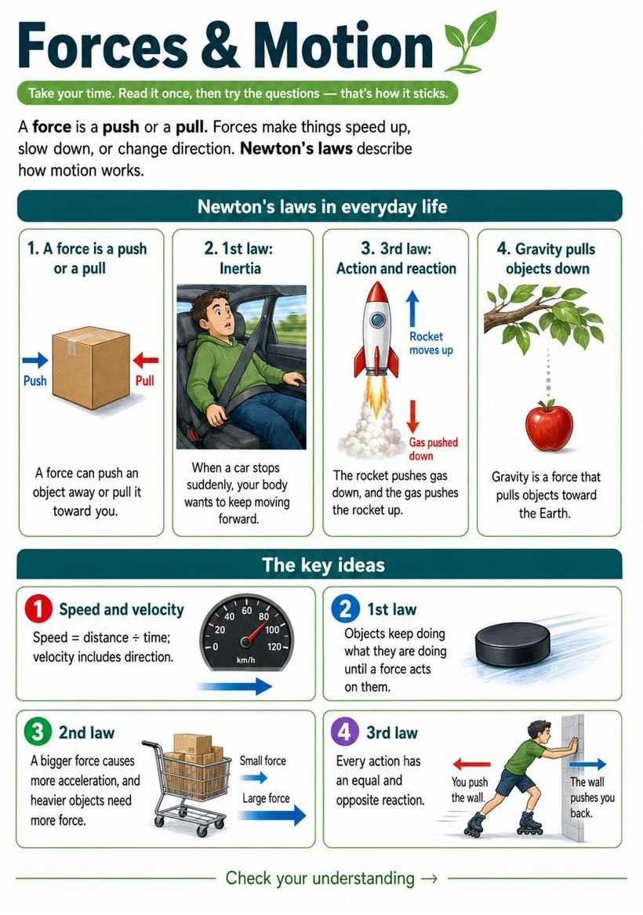
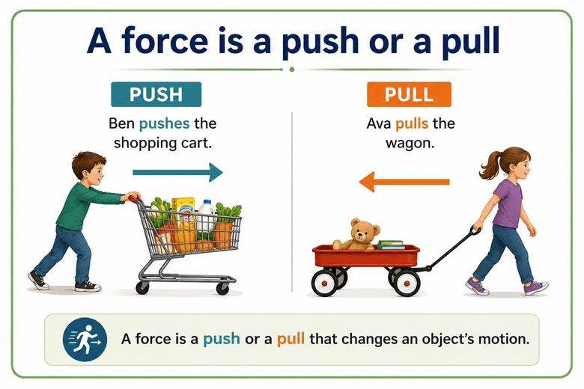
Questions
1. An object at rest stays at rest unless a force acts on it. This idea is called:
A. Gravity
B. Inertia
C. Friction
D. Energy
2. A car travels 150 miles in 3 hours. What is its average speed in miles per hour? (Type the number)
Answer: ______________________________

Energy
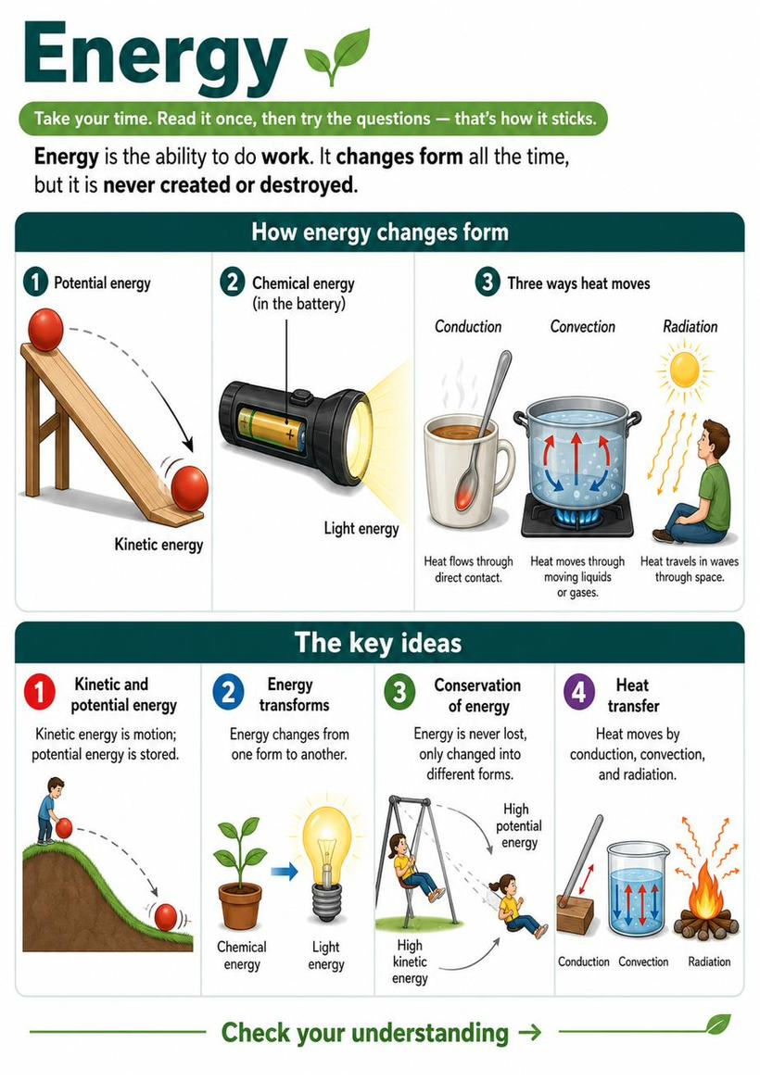
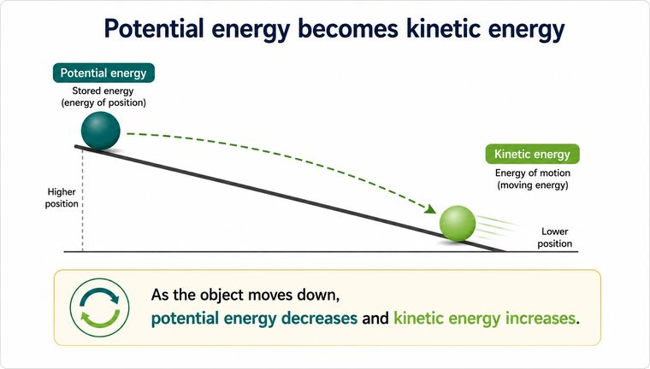
Questions
1. Which is an example of stored (potential) energy?
A. A car driving
B. A book on a high shelf
C. A rolling ball
D. A spinning fan
2. When you rub your hands together, they warm up. Friction turns motion energy into:
A. Light
B. Sound
C. Thermal (heat) energy
D. Chemical energy

Waves, Light & Electricity
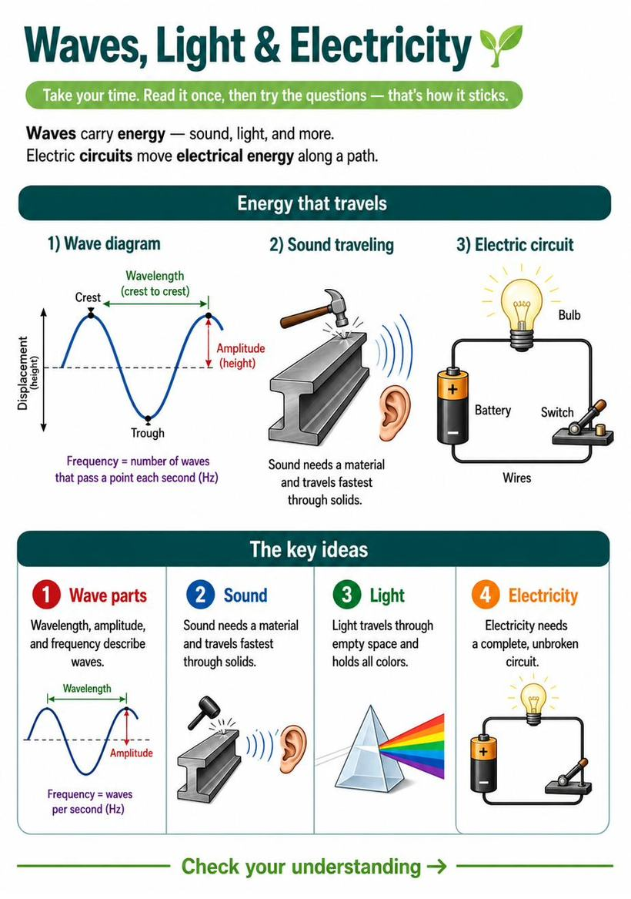
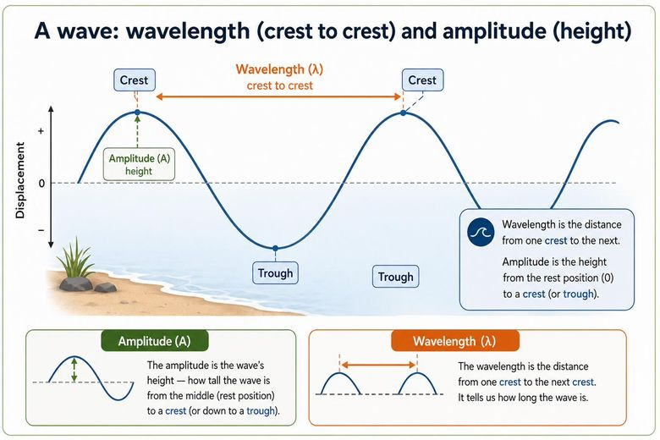
Questions
1. On the wave shown, the distance labeled X (crest to crest) is the wave's:
A. Amplitude
B. Wavelength
C. Frequency
D. Speed
2. Sound travels fastest through which material?
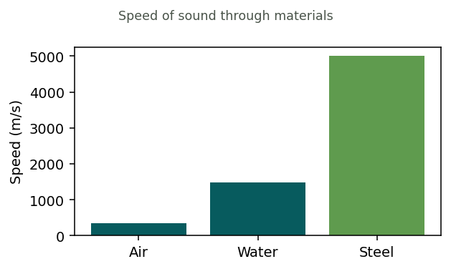
A. Air
B. Water
C. Steel
D. Equal

Magnetism
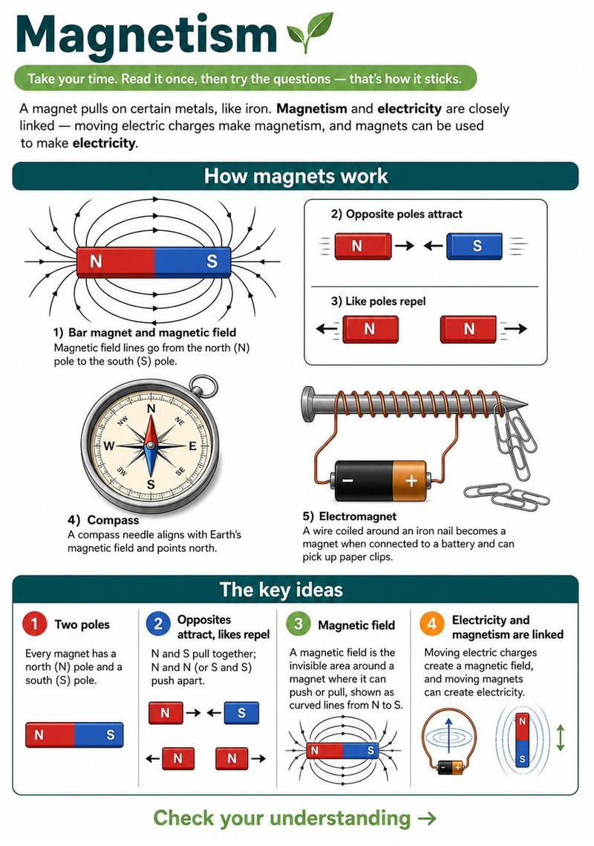
Questions
1. Every magnet has how many poles?
A. One
B. Two
C. Three
D. None
2. What happens when you bring two NORTH poles close together?
A. They attract (pull together)
B. They repel (push apart)
C. Nothing happens
D. They melt
3. The invisible area around a magnet where it can push or pull is called the:
A. Magnetic field
B. Circuit
C. Current
D. Pole
4. An electromagnet is made by:
A. Rubbing two magnets together
B. Running electric current through a coil of wire
C. Heating iron
D. Freezing a magnet

Reading an Article: Renewable Energy
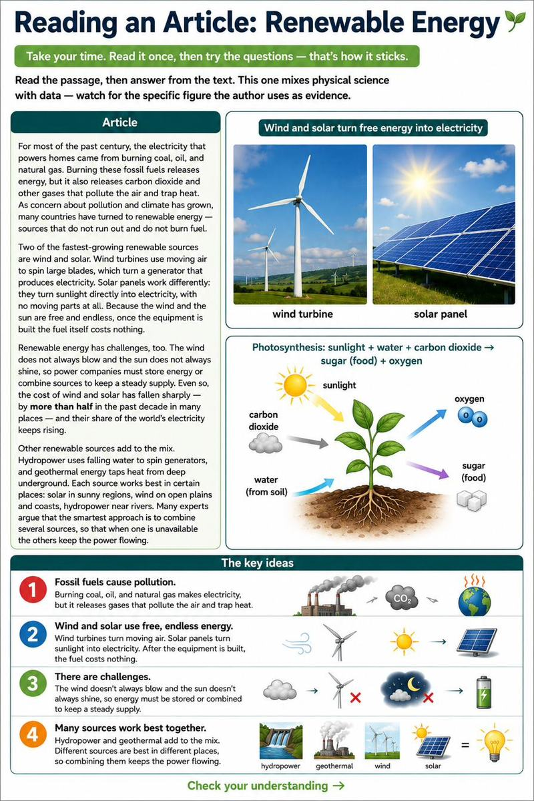
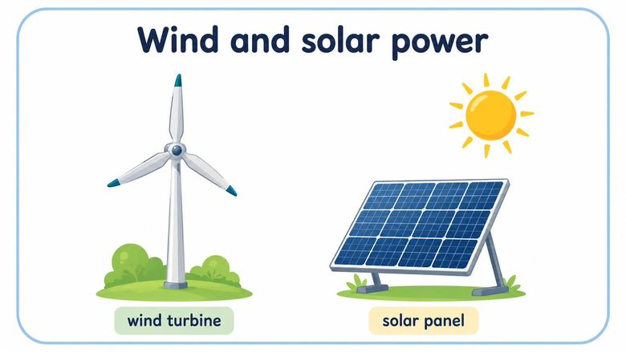
Questions
1. What is the main idea of the passage?
A. Fossil fuels are cheap
B. Wind and solar are growing as clean alternatives to fossil fuels
C. Solar panels have moving parts
D. The wind always blows
2. According to the passage, how does a wind turbine make electricity?
A. It burns fuel
B. Moving air spins blades that turn a generator
C. Sunlight hits a panel
D. It stores heat
3. In the passage, 'renewable energy' means sources that:
A. Burn cleanly
B. Do not run out and do not burn fuel
C. Are always available
D. Cost nothing to build
4. Based on the passage, a real challenge for wind and solar is that:
A. They cost too much fuel
B. The wind and sun are not always available
C. They pollute the air
D. They cannot make electricity

Reading an Article: Sound and How We Hear
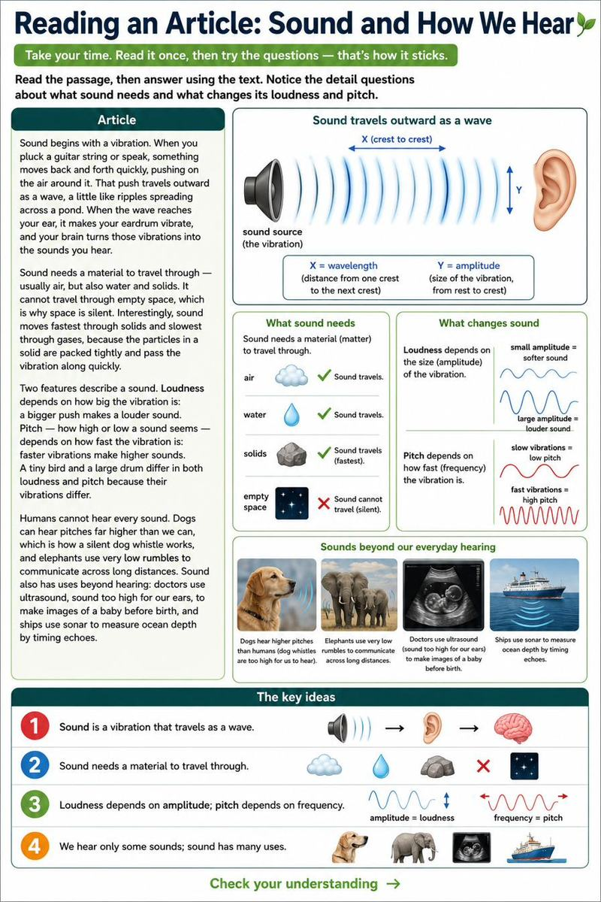
Questions
1. What is the main idea of the passage?
A. Guitars are loud
B. How sound is made, travels, and is described
C. Space is silent
D. Ears are complicated
2. According to the passage, what does sound need in order to travel?
A. Bright light
B. A material such as air, water, or a solid
C. Empty space
D. Electricity
3. The passage says sound travels FASTEST through:
A. Gases
B. Liquids
C. Solids
D. Empty space
4. Based on the passage, why is space silent?
A. Space is too cold
B. There is no material for sound to travel through
C. Sound is too weak
D. No one is listening

Reading an Article: Forces and Motion
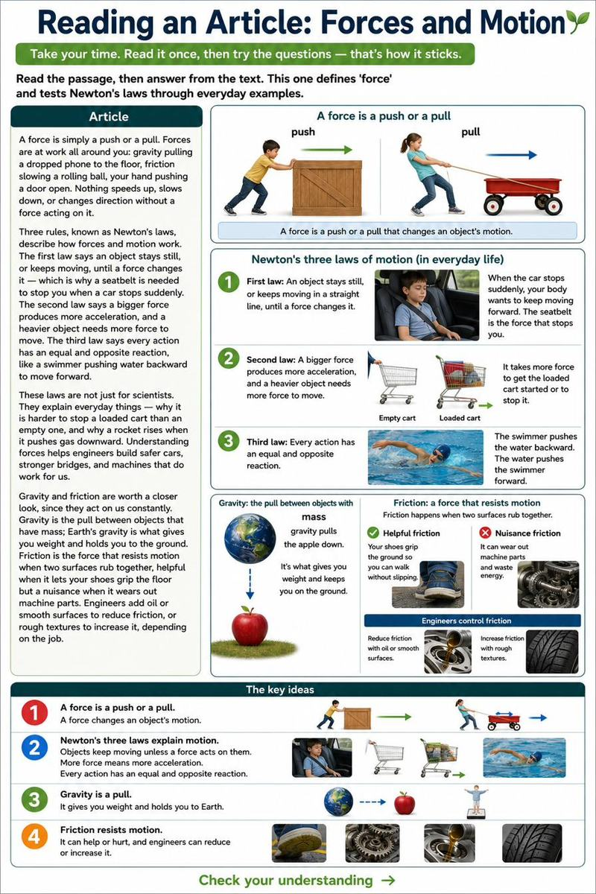
Questions
1. What is the main idea of the passage?
A. Cars are dangerous
B. How forces and Newton's laws explain motion
C. Rockets are fast
D. Doors are heavy
2. In the passage, a 'force' is defined as:
A. A kind of energy
B. A push or a pull
C. A moving object
D. A type of speed
3. According to the passage, why do you need a seatbelt when a car stops suddenly?
A. Cars are heavy
B. A moving object keeps moving until a force stops it (Newton's first law)
C. Seatbelts add speed
D. Gravity pulls you down
4. Based on the passage, why is it harder to stop a loaded cart than an empty one?
A. The loaded cart is colder
B. A heavier object needs more force to change its motion
C. Empty carts have no wheels
D. Loaded carts move faster on their own

Reading an Article: Chemical Changes
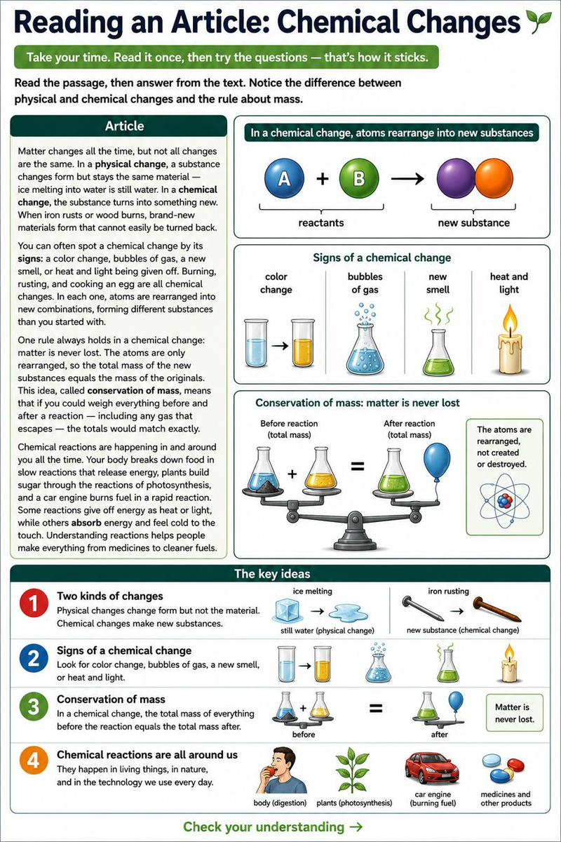
Questions
1. What is the main idea of the passage?
A. Ice is cold
B. The difference between physical and chemical changes, and that matter is conserved
C. Eggs are food
D. Rust is red
2. According to the passage, which is an example of a PHYSICAL change?
A. Iron rusting
B. Wood burning
C. Ice melting into water
D. An egg cooking
3. According to the passage, which is a sign of a chemical change?
A. The object gets wet
B. A color change, gas bubbles, or heat and light given off
C. The object moves
D. The object gets colder only
4. Based on the passage, a nail rusting is a chemical change because:
A. The nail gets wet
B. A brand-new material forms that can't easily be turned back
C. The nail changes shape
D. The nail gets colder

