Earth & Space Science Study Book
Diagrams & Practice Questions — Student Edition
GED & HiSET Science · GRDM Publishing, LLC · gingertheteacher.com
Study the diagram, then circle the best answer for each question.
Name: _______________________________ Date: ______________

Earth's Structure & Plate Tectonics
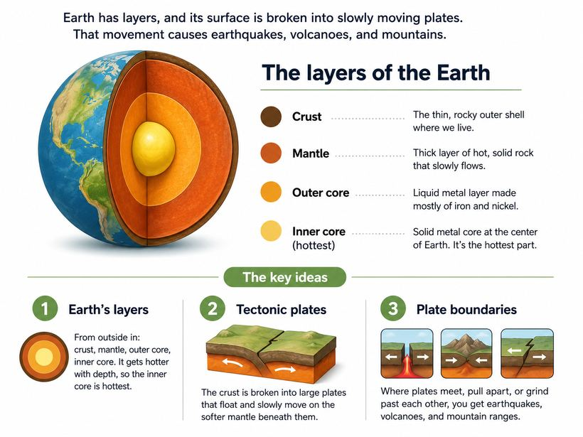
Questions
1. Earthquakes and volcanoes happen most often where:
A. Rivers meet the ocean
B. Tectonic plates meet
C. Deserts form
D. Forests grow
2. Which layer of the Earth is the hottest?
A. The crust
B. The mantle
C. The outer core
D. The inner core

Rocks, Minerals & Earth's Cycles
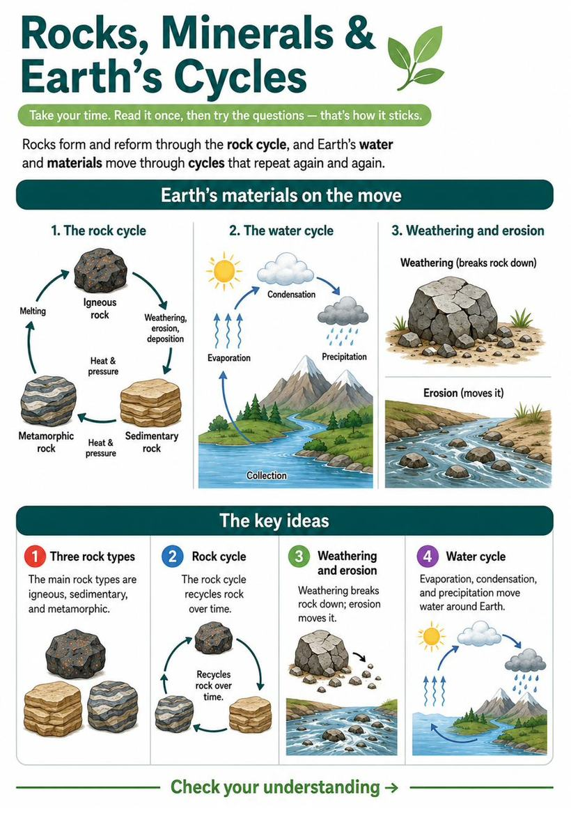
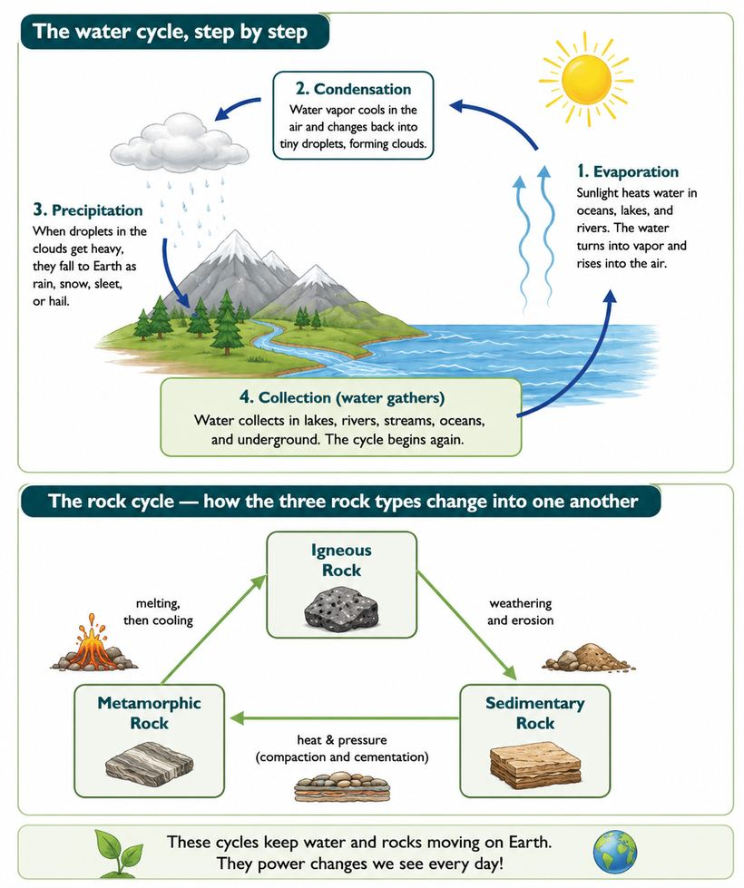
Questions
1. A rock that forms when melted lava cools and hardens is:
A. Sedimentary
B. Igneous
C. Metamorphic
D. A fossil
2. Water vapor cooling into liquid droplets that form clouds is called:
A. Evaporation
B. Condensation
C. Erosion
D. Precipitation

Weather & Climate
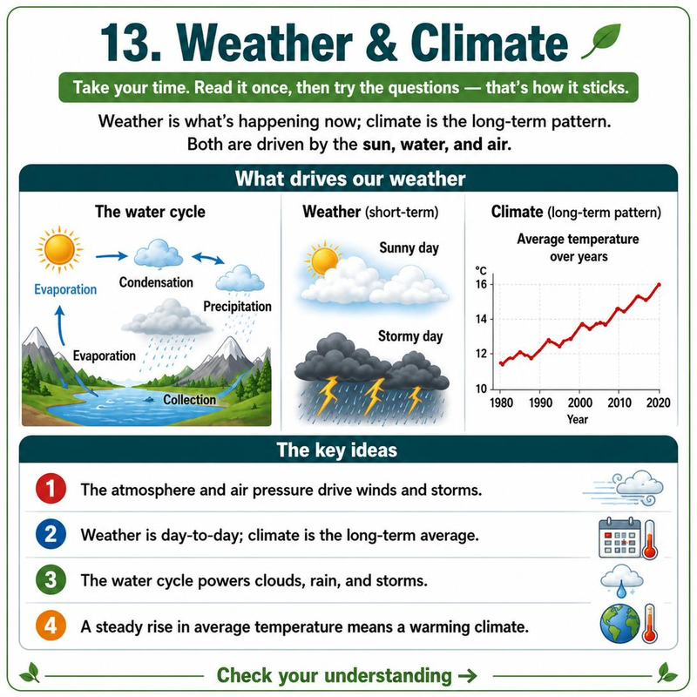
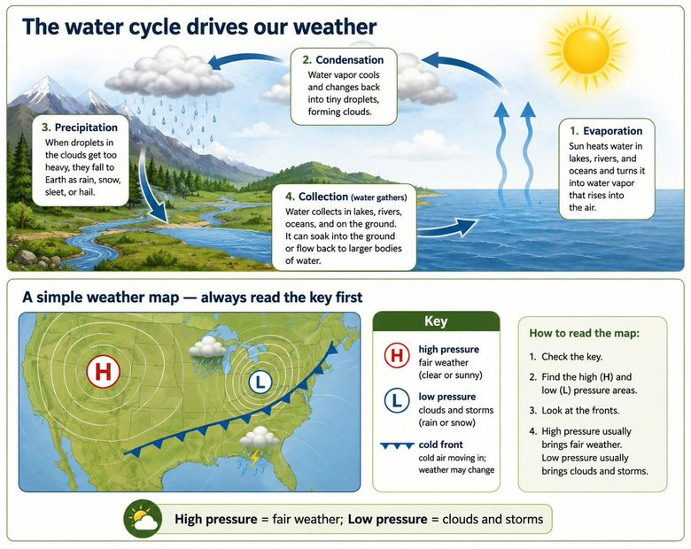
Questions
1. On this weather map, what does the H stand for?
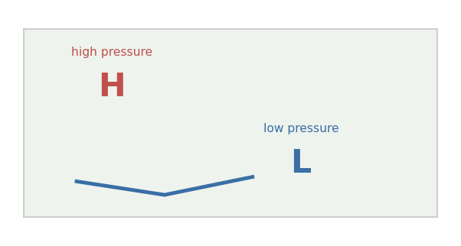
A. Heat
B. High pressure
C. Humidity
D. Hurricane
2. Which usually brings clouds and storms?
A. High pressure (H)
B. Low pressure (L)
C. The key
D. Fair skies
3. Which month was the warmest?
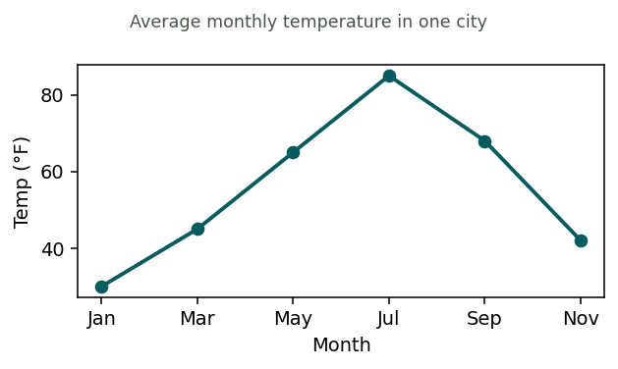
A. January
B. March
C. July
D. November
4. Based on the trend, the average global temperature is:
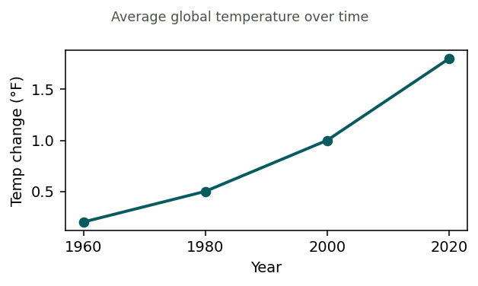
A. Decreasing
B. Staying the same
C. Increasing
D. Rising then falling

Astronomy: Earth, Moon & Beyond
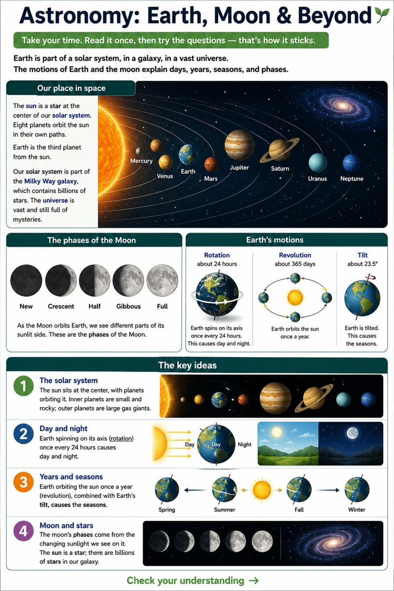
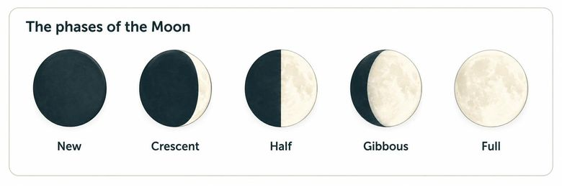
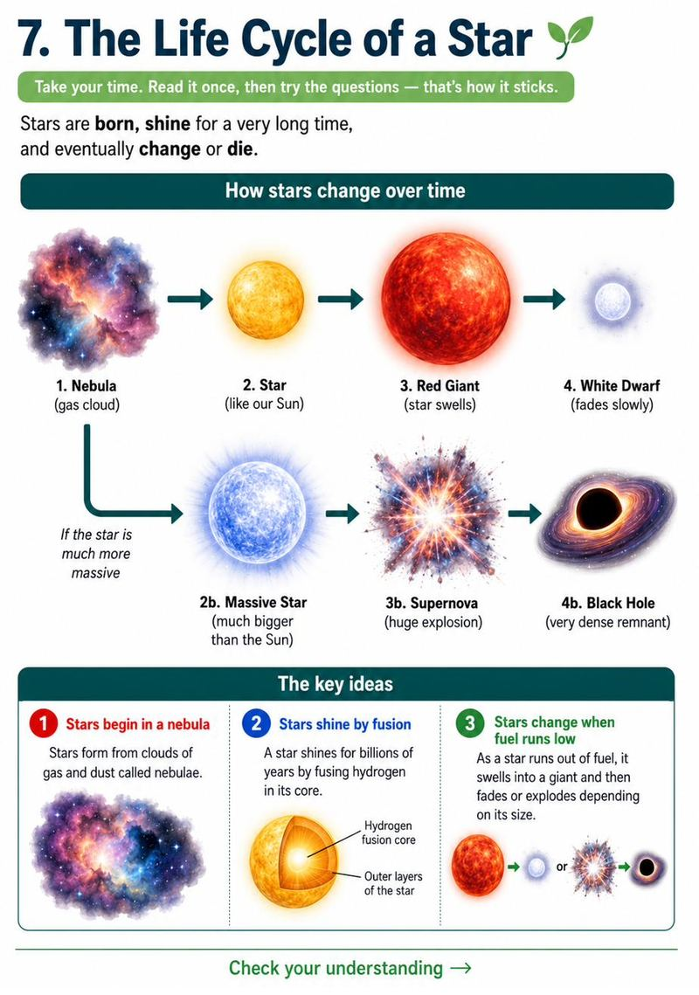
Questions
1. Stars form from giant clouds of:
A. Water
B. Gas and dust (a nebula)
C. Rock
D. Ice
2. A very large star may end its life by exploding as a:
A. White dwarf
B. Supernova
C. Comet
D. Planet
3. Which planet is farthest from the Sun?
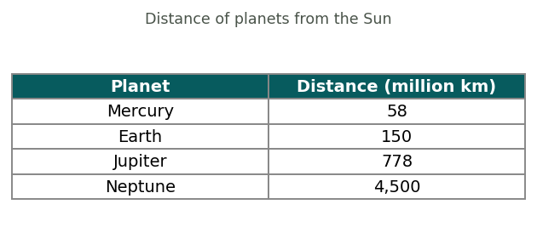
A. Mercury
B. Earth
C. Jupiter
D. Neptune
4. What causes day and night on Earth?
A. Earth orbiting the sun
B. Earth spinning on its axis
C. The moon's phases
D. The tilt of Earth

Reading an Article: Coral Reefs & Warming Seas
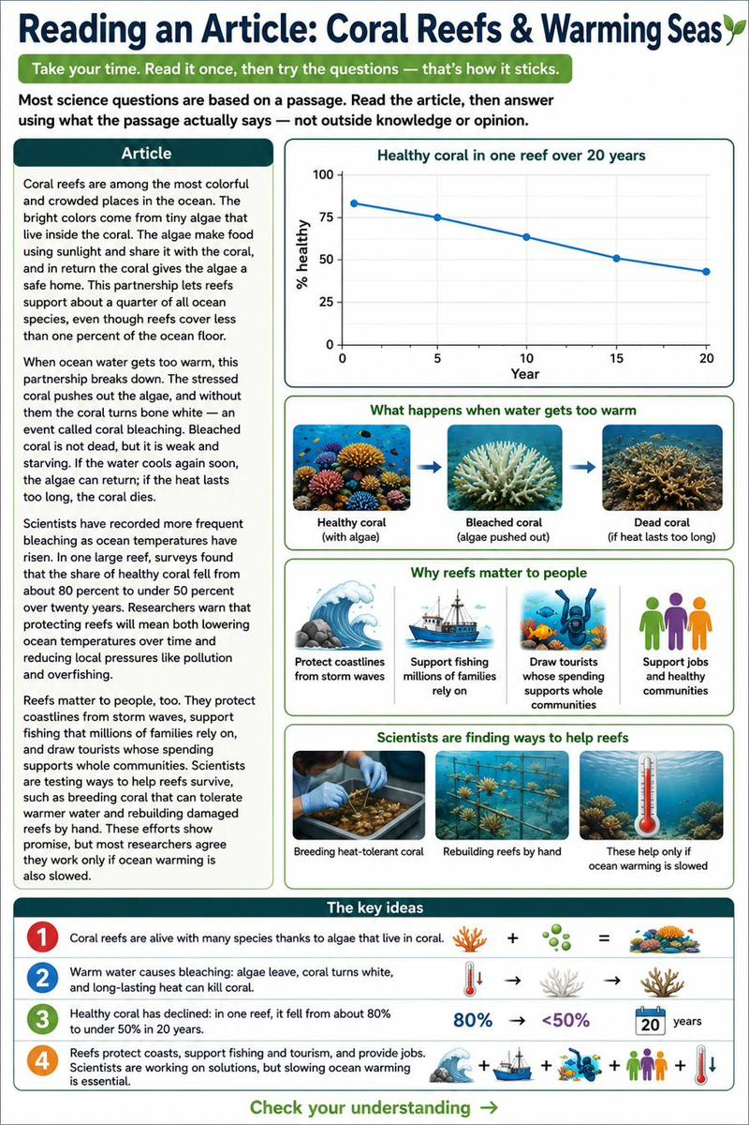
Questions
1. What is the main idea of the passage?
A. Coral reefs are very colorful
B. Warming oceans threaten coral reefs and the life they support
C. Algae live inside coral
D. Reefs cover less than 1% of the ocean
2. According to the passage, what do the algae give the coral?
A. A safe home
B. Food made from sunlight
C. A bright white color
D. Cooler water
3. In the passage, 'coral bleaching' refers to coral that has:
A. Grown much larger
B. Turned white after losing its algae
C. Been cleaned by divers
D. Changed into a new species
4. Based on the passage, bleached coral is most likely to recover if:
A. The water cools again soon
B. The heat lasts a long time
C. More algae are removed
D. Fishing increases nearby

Reading an Article: What Causes Earthquakes
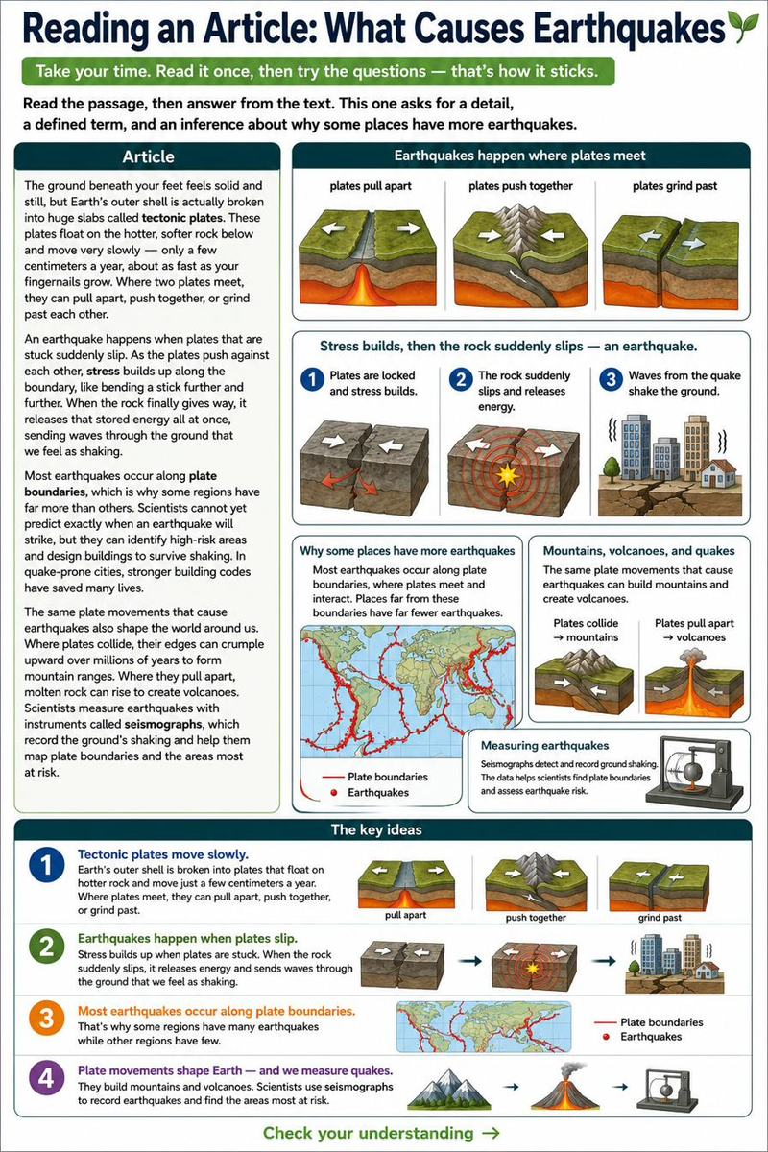
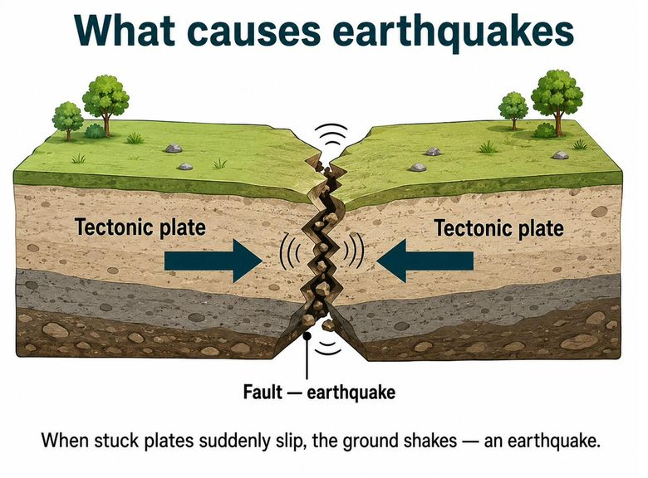
Questions
1. What is the main idea of the passage?
A. The ground is always still
B. What causes earthquakes and how people prepare for them
C. Fingernails grow slowly
D. Buildings are dangerous
2. According to the passage, how fast do tectonic plates move?
A. A few meters a day
B. A few centimeters a year
C. Hundreds of miles an hour
D. They do not move
3. In the passage, 'tectonic plates' are:
A. Ocean waves
B. Huge slabs of Earth's outer shell
C. Layers of the atmosphere
D. Types of rock
4. Based on the passage, why do some regions have far more earthquakes than others?
A. They have taller buildings
B. They sit along plate boundaries
C. They are colder
D. They have more people

Reading an Article: Why the Moon Changes Shape
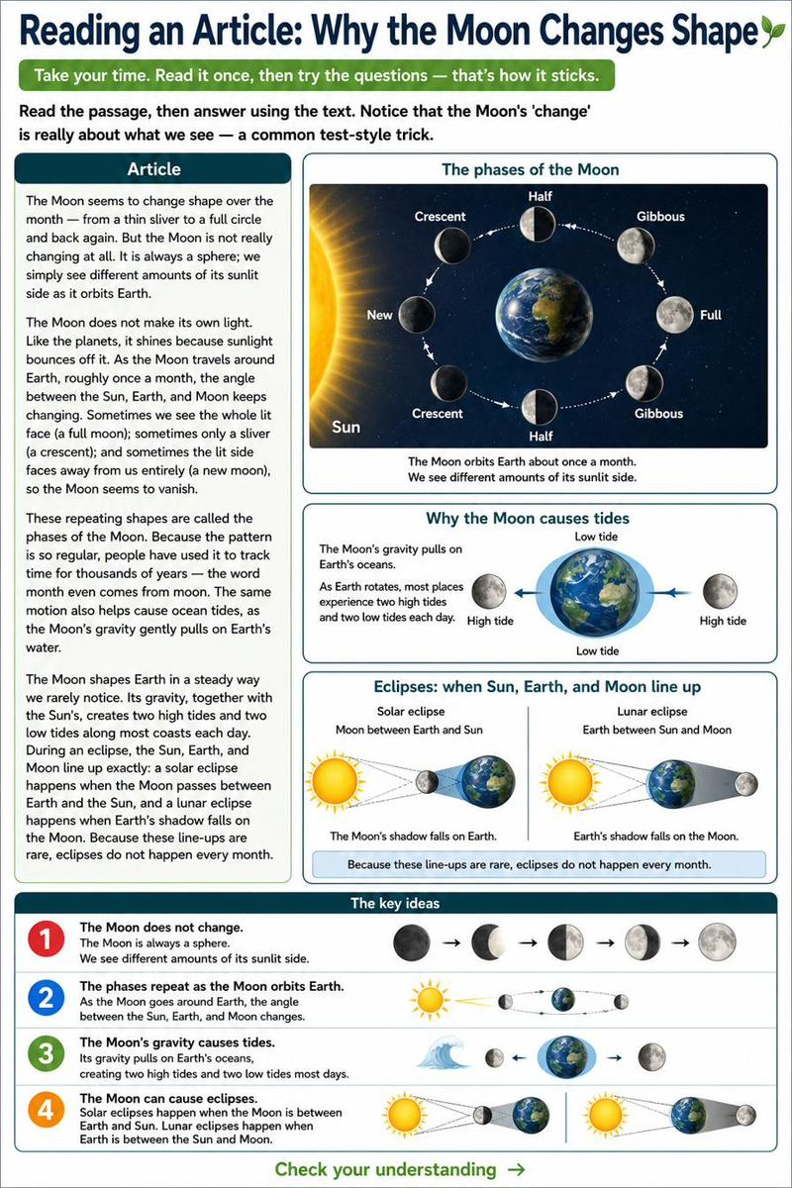
Questions
1. What is the main idea of the passage?
A. The Moon grows and shrinks
B. Why the Moon appears to change shape as it orbits Earth
C. The Moon makes its own light
D. Months are long
2. According to the passage, why does the Moon shine?
A. It burns like the Sun
B. Sunlight bounces off it
C. It glows on its own
D. Earth lights it up
3. In the passage, the 'phases' of the Moon are:
A. The Moon's craters
B. The repeating shapes of the lit Moon we see
C. The Moon's orbit speed
D. The Moon's gravity
4. Based on the passage, during a new moon the Moon seems to vanish because:
A. It moves far away
B. Its lit side faces away from us
C. It stops orbiting
D. Clouds cover it

Reading an Article: Weather and the Water Cycle
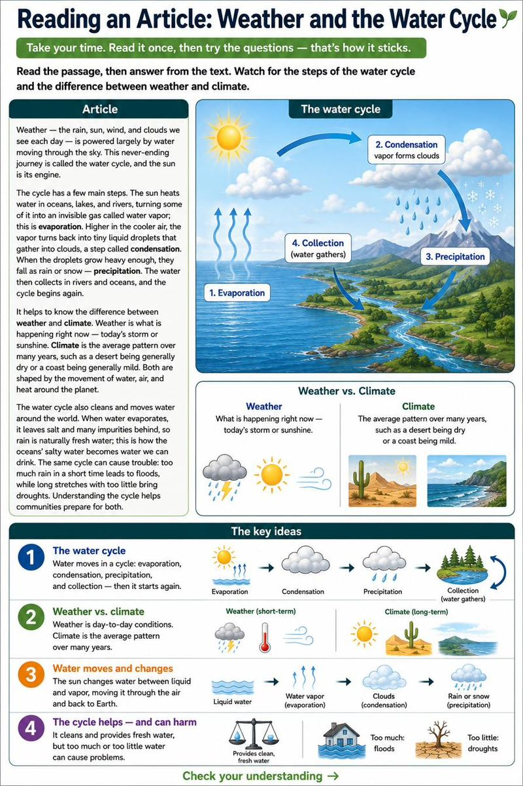
Questions
1. What is the main idea of the passage?
A. Rain is wet
B. How the water cycle drives weather, and how weather differs from climate
C. The sun is hot
D. Deserts are dry
2. According to the passage, what powers the water cycle?
A. The wind
B. The sun
C. The ocean
D. Clouds
3. In the passage, 'condensation' is the step where:
A. Water is heated into vapor
B. Vapor turns back into liquid droplets and forms clouds
C. Rain falls to the ground
D. Water collects in rivers
4. According to the passage, precipitation is:
A. Water evaporating
B. Vapor forming clouds
C. Rain or snow falling from clouds
D. Water heating up

Reading an Article: Rocks and Earth's Resources
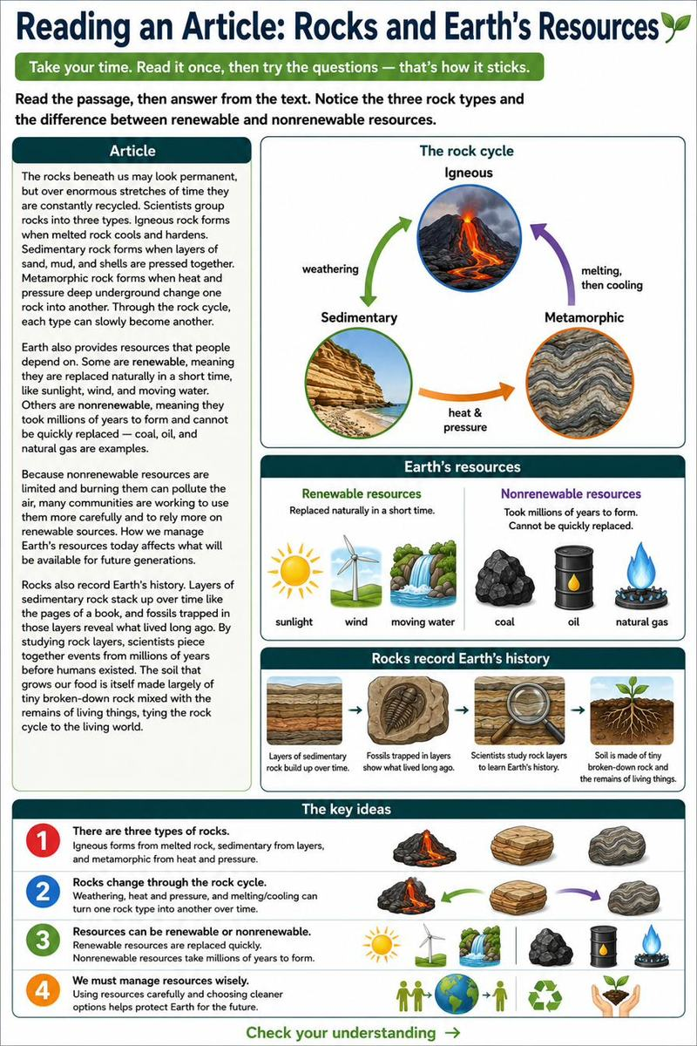
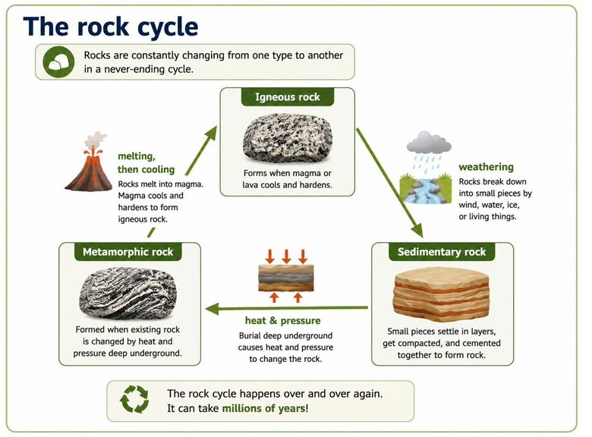
Questions
1. What is the main idea of the passage?
A. Rocks are hard
B. Rocks are recycled over time, and Earth's resources are renewable or nonrenewable
C. Coal is black
D. Sand is everywhere
2. According to the passage, igneous rock forms when:
A. Layers are pressed together
B. Melted rock cools and hardens
C. Heat and pressure change a rock
D. Water washes over it
3. In the passage, a 'nonrenewable' resource is one that:
A. Is replaced quickly by nature
B. Took millions of years to form and can't be quickly replaced
C. Comes from the sun
D. Is found only in oceans
4. Based on the passage, why are many communities turning to renewable resources?
A. They are prettier
B. Nonrenewable resources are limited and burning them can pollute
C. They are harder to use
D. They took longer to form

