Life Science Study Book
Diagrams, Questions & Answers
GED & HiSET Science · GRDM Publishing, LLC · gingertheteacher.com
Study the diagram, then answer the questions. Correct answers are marked in bold.

Cells & Cell Processes
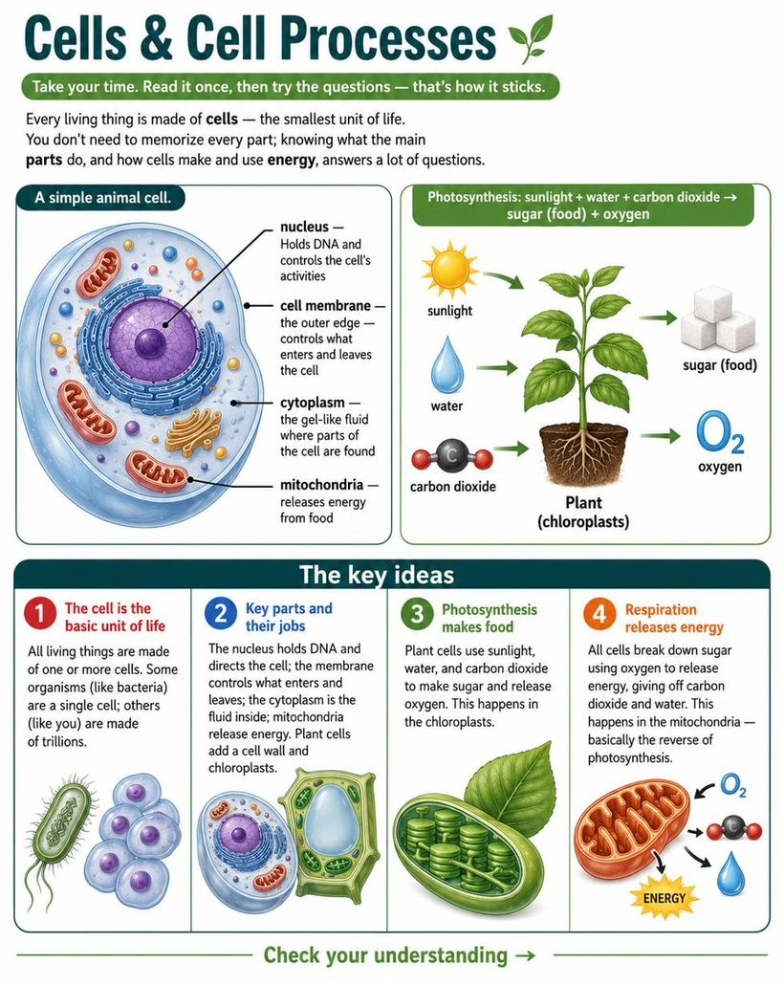
Questions
1. How does the body make new cells to heal a cut?
A. Cells appear from nothing
B. Existing cells divide in two ✓
C. The heart makes them
D. Food turns straight into cells
Answer: B. New cells come from existing cells dividing. This lets living things grow and repair damage.
2. Which biomolecule is mainly used to BUILD and REPAIR the body?
A. Carbohydrates
B. Proteins ✓
C. Fats
D. Water
Answer: B. Proteins build and repair body tissues; carbohydrates and fats are mainly for energy.
3. Which part of a cell contains its DNA and directs its activities?
A. Cell membrane
B. Nucleus ✓
C. Cytoplasm
D. Cell wall
Answer: B. The nucleus holds the cell's DNA and acts as its control center.
4. Green plants make food from sunlight, water, and carbon dioxide. This process is:
A. Respiration
B. Digestion
C. Photosynthesis ✓
D. Evaporation
Answer: C. Photosynthesis turns sunlight, water, and carbon dioxide into sugar and oxygen.

Human Body Systems
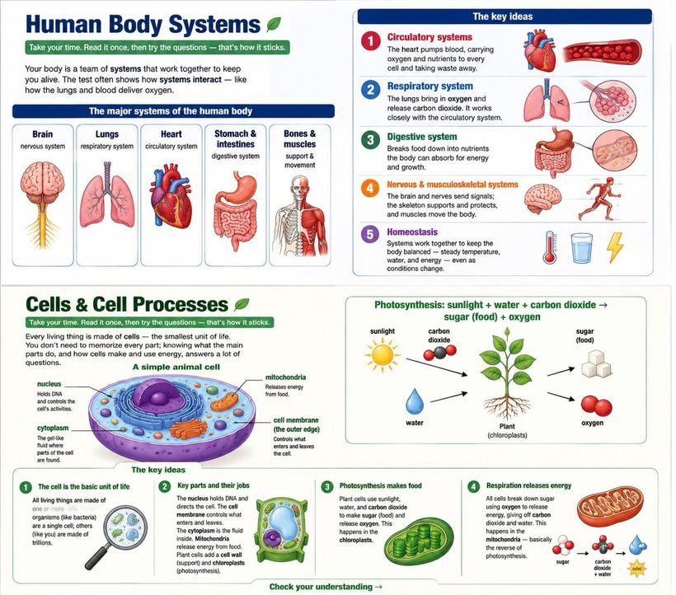
Questions
1. What is the main idea of this passage?
A. The heart is the most important organ
B. The body's systems each have a job and work together to keep it alive ✓
C. Blood carries oxygen
D. Bones support the body
Answer: B. The passage is mostly about how the body's systems work together, which is its main idea.
2. In the passage, keeping the body balanced and alive is called:
A. Digestion
B. Homeostasis ✓
C. Respiration
D. Circulation
Answer: B. The passage says keeping the body balanced is a process called homeostasis.
3. Which of the following is NOT a job of the skeletal system?
A. Supporting the body
B. Protecting organs
C. Pumping blood ✓
D. Working with muscles to move
Answer: C. Pumping blood is the heart's job. The skeleton supports, protects, and helps with movement.
4. Which two systems work together to get oxygen into the blood?
A. Digestive and nervous
B. Respiratory and circulatory ✓
C. Skeletal and muscular
D. Digestive and circulatory
Answer: B. The lungs (respiratory) take in oxygen, and the blood (circulatory) carries it through the body.

Genetics & Heredity
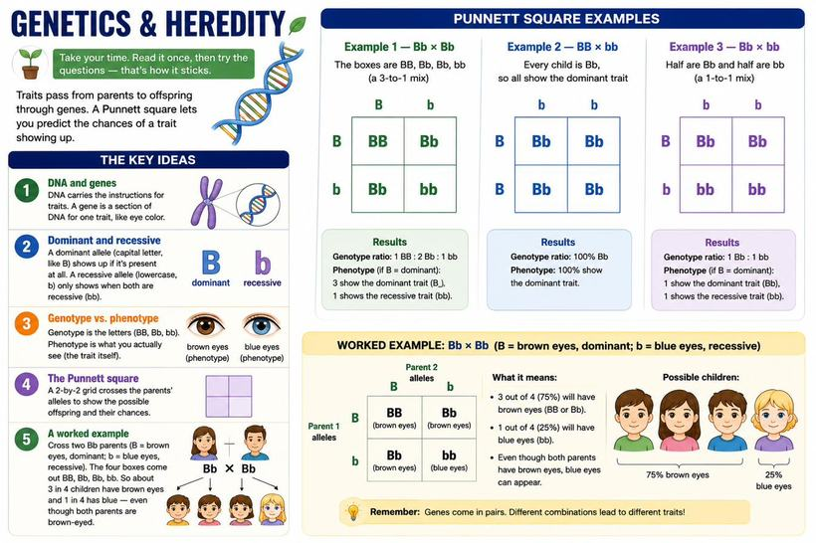
Questions
1. In a Bb × Bb cross, what percent of the offspring are expected to show the RECESSIVE trait?
A. 0%
B. 25% ✓
C. 50%
D. 75%
Answer: B. Only bb shows the recessive trait, and bb is 1 of the 4 boxes = 25%. The other three (BB, Bb, Bb) show the dominant trait.
2. Inside the nucleus, DNA is packed into structures called:
A. Chromosomes ✓
B. Mitochondria
C. Membranes
D. Ribosomes
Answer: A. DNA is organized into chromosomes; humans have 46 (23 pairs) in most cells, and genes are sections of DNA on them.
3. If both parents are Bb, what fraction of offspring are expected to be bb?
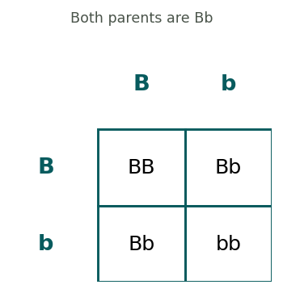
A. 1/4 ✓
B. 1/2
C. 3/4
D. 0
Answer: A. The boxes are BB, Bb, Bb, bb. Only one of four is bb, so 1/4.
4. What fraction of the offspring are expected to be tall (have at least one T)?
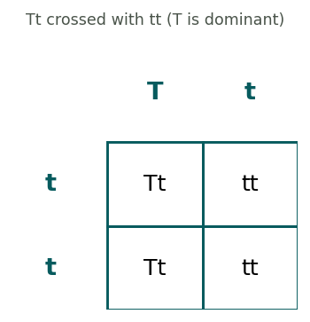
A. 1/4
B. 1/2 ✓
C. 3/4
D. All
Answer: B. The boxes are Tt, Tt, tt, tt. Two of four carry a T, so 1/2 are tall.
5. An allele that shows up only when two copies are present is called:
A. Dominant
B. Recessive ✓
C. A phenotype
D. A gene
Answer: B. A recessive trait appears only when both alleles are recessive (like bb).
6. In this BB × bb cross, what genotype will ALL of the offspring have?
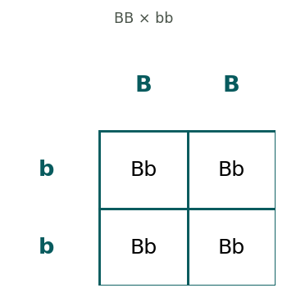
A. BB
B. Bb ✓
C. bb
D. A mix of all three
Answer: B. Each child gets a B from one parent and a b from the other, so every box is Bb.
7. In a Bb × Bb cross, what is the genotype ratio of the offspring?
A. 1 BB : 2 Bb : 1 bb ✓
B. All Bb
C. 1 BB : 1 bb
D. 3 BB : 1 bb
Answer: A. The four boxes are BB, Bb, Bb, and bb — a ratio of 1 BB to 2 Bb to 1 bb.
8. B (brown eyes) is dominant over b (blue eyes). In a Bb × Bb cross, what fraction of children are expected to have BROWN eyes?
A. 1/4
B. 1/2
C. 3/4 ✓
D. All
Answer: C. Three of the four boxes (BB, Bb, Bb) have at least one B, so 3/4 show the dominant brown trait.
9. In this Bb × bb cross, what fraction of the offspring are bb?
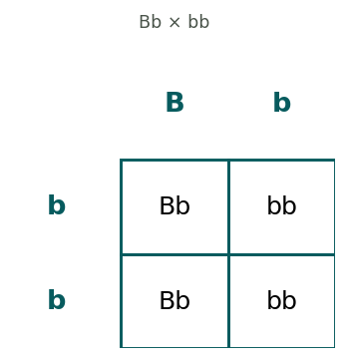
A. 1/4
B. 1/2 ✓
C. 3/4
D. 0
Answer: B. The boxes are Bb, Bb, bb, bb — two of the four are bb, so 1/2.
10. A person who carries one recessive allele hidden behind a dominant one (like Bb) is called a:
A. Twin
B. Carrier ✓
C. Clone
D. Donor
Answer: B. A carrier has the recessive allele but doesn't show the trait, and can still pass it on to children.
11. Which of these describes a PHENOTYPE rather than a genotype?
A. Bb
B. BB
C. Brown eyes ✓
D. bb
Answer: C. A phenotype is the trait you can see, like brown eyes. BB, Bb, and bb are genotypes — the letter combinations.

Evolution & Natural Selection
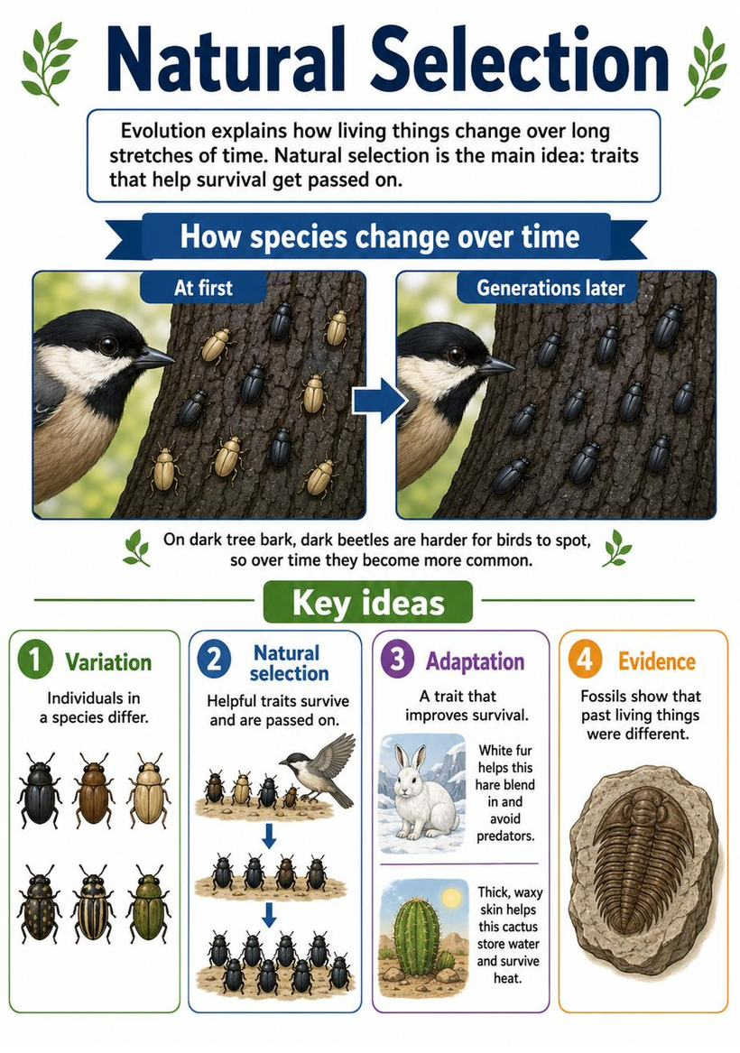
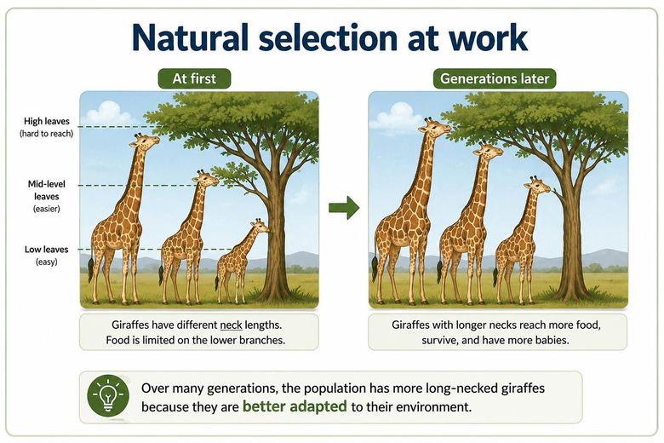
Questions
1. In a dark forest, dark moths are hidden from birds while light moths get eaten. Over time, most moths become dark. This is an example of:
A. Photosynthesis
B. Natural selection ✓
C. Homeostasis
D. Erosion
Answer: B. The trait that helps survival (dark color) gets passed on more often — that's natural selection.
2. A trait that helps an organism survive in its environment is called:
A. A mutation
B. An adaptation ✓
C. A phenotype
D. A control
Answer: B. An adaptation is a helpful trait that improves an organism's chances of surviving and reproducing.

Ecosystems & Energy Flow
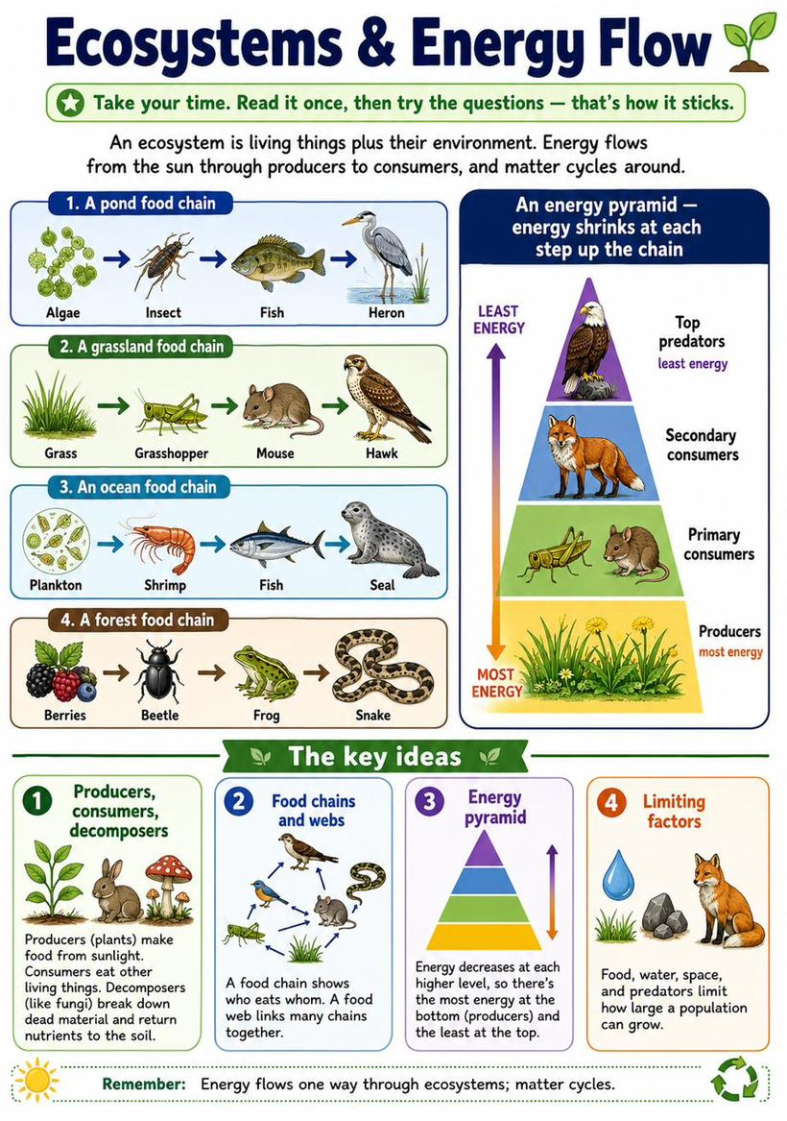
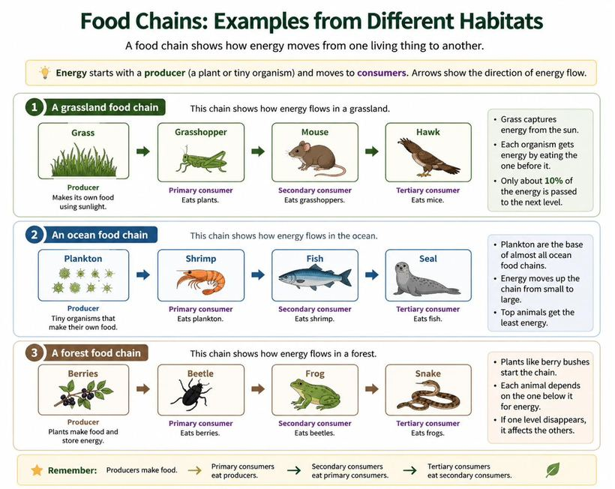
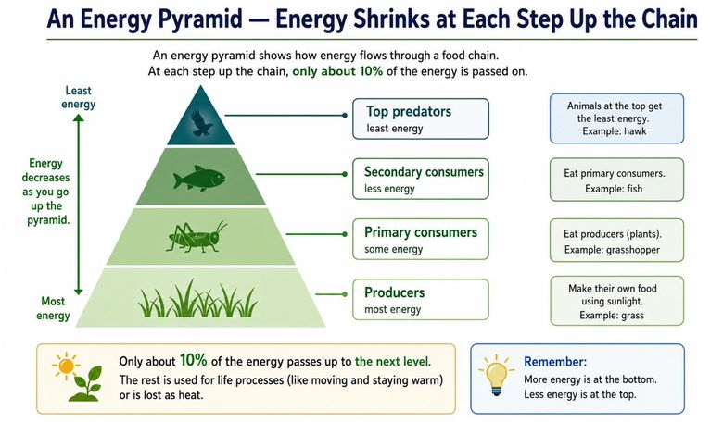
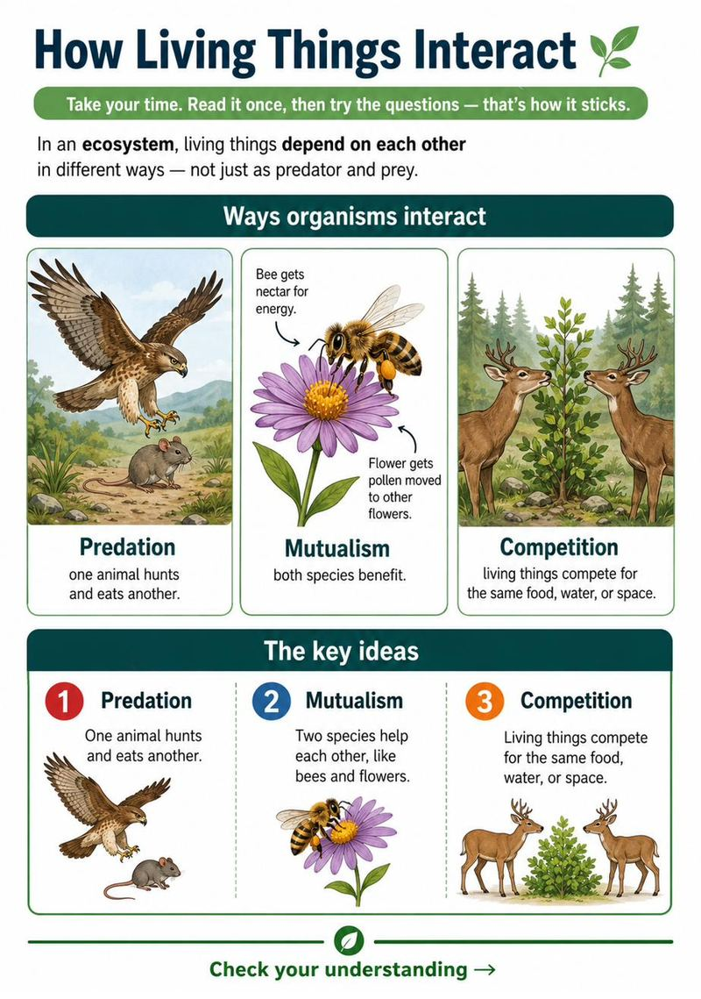
Questions
1. The largest population an ecosystem can support over time is called its:
A. Food web
B. Carrying capacity ✓
C. Energy pyramid
D. Habitat
Answer: B. Carrying capacity is the maximum population an ecosystem's resources can support.
2. Bees and flowers helping each other is an example of:
A. Predation
B. Mutualism ✓
C. Competition
D. Erosion
Answer: B. In mutualism, both species benefit — bees get food and flowers get pollinated.
3. Two deer feeding from the same small patch of grass are in:
A. Mutualism
B. Predation
C. Competition ✓
D. Cooperation
Answer: C. Competition is when living things need the same limited resource — here, the same food.
4. What is the main idea of this passage?
A. Plants are green
B. How energy and matter move through an ecosystem ✓
C. Predators are dangerous
D. Soil is important
Answer: B. The passage is mostly about how energy flows and matter cycles through an ecosystem.
5. Based on the passage, why are there fewer top predators than plants?
A. Predators are bigger
B. Energy shrinks at each step of the chain ✓
C. Plants reproduce quickly
D. There is a rule against predators
Answer: B. The passage explains energy shrinks at each step, so less is available higher up — a fair inference.
6. In this food chain, which organism is the primary consumer?
Algae → Insect → Fish → Heron
A. Algae
B. Insect ✓
C. Fish
D. Heron
Answer: B. The primary consumer eats the producer. Algae is the producer, so the insect that eats it is the primary consumer.
7. Which level of the food chain has the most available energy?
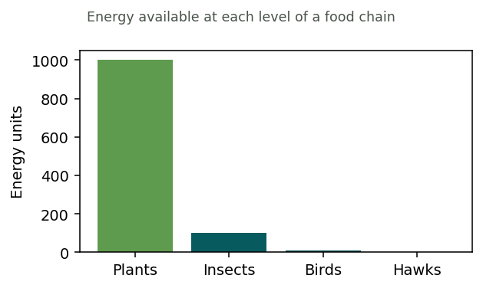
A. Plants ✓
B. Insects
C. Birds
D. Hawks
Answer: A. Energy shrinks at each higher level, so producers (plants) start with the most.
8. What is the main role of decomposers in an ecosystem?
A. To make food from sunlight
B. To break down dead material and recycle nutrients ✓
C. To hunt large animals
D. To produce oxygen
Answer: B. Decomposers break down dead plants and animals, returning nutrients to the soil for producers to reuse.
9. In this grassland food chain, which organism is the producer?
Grass → Grasshopper → Mouse → Hawk
A. Grass ✓
B. Grasshopper
C. Mouse
D. Hawk
Answer: A. The producer makes its own food from sunlight. Grass is the producer; everything else eats to get energy.
10. Which organism is the primary consumer — the first to eat the producer?
Grass → Grasshopper → Mouse → Hawk
A. Grass
B. Grasshopper ✓
C. Mouse
D. Hawk
Answer: B. The grasshopper eats the grass (the producer), so it is the primary consumer.
11. In this ocean food chain, which organism is the top predator?
Plankton → Shrimp → Fish → Seal
A. Plankton
B. Shrimp
C. Fish
D. Seal ✓
Answer: D. The seal is at the end of the chain and nothing eats it here, so it is the top predator.
12. Which organism is a secondary consumer — it eats the primary consumer?
Plankton → Shrimp → Fish → Seal
A. Plankton
B. Shrimp
C. Fish ✓
D. Seal
Answer: C. Shrimp eat the plankton (making shrimp the primary consumer), and the fish eat the shrimp, so the fish is a secondary consumer.
13. If the beetles disappeared from this food chain, what would most likely happen to the frogs?
Berries → Beetle → Frog → Snake
A. They would have more food
B. They would have less food ✓
C. Nothing would change
D. They would become producers
Answer: B. The frogs eat beetles here, so losing the beetles means the frogs lose a food source.

Reading an Article: How Vaccines Work
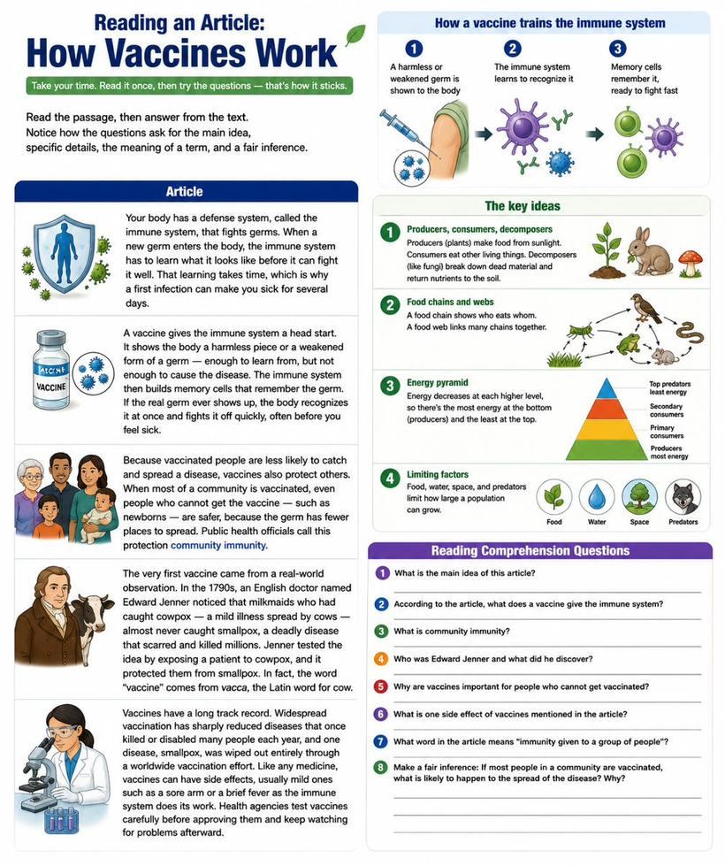
Questions
1. What is the main idea of the passage?
A. The immune system is slow
B. How vaccines help the body fight disease ✓
C. Newborns get sick easily
D. Germs are everywhere
Answer: B. The passage is mostly about how vaccines prepare the body to fight disease.
2. According to the passage, what does a vaccine show the body?
A. A strong, full-strength germ
B. A harmless piece or weakened form of a germ ✓
C. A memory cell
D. A dose of medicine
Answer: B. The passage says a vaccine shows a harmless piece or weakened form of a germ — enough to learn from, not enough to cause disease.
3. In the passage, 'memory cells' are cells that:
A. Store your thoughts
B. Remember a germ so the body can fight it faster later ✓
C. Make you feel sick
D. Replace the vaccine
Answer: B. The passage explains that memory cells remember the germ so the body reacts quickly next time.
4. Why can a first infection make you sick for several days?
A. The germ is stronger the first time
B. The immune system needs time to learn the new germ ✓
C. Vaccines wear off
D. Memory cells attack the body
Answer: B. The passage says the immune system has to learn a new germ before it can fight it well, and that takes time.
5. 'Community immunity' most helps people who:
A. Are already vaccinated
B. Cannot get the vaccine, such as newborns ✓
C. Never leave home
D. Make vaccines
Answer: B. The passage says community immunity protects those who cannot get the vaccine, like newborns, because the germ has fewer places to spread.
6. According to the passage, how did Edward Jenner get the idea for the first vaccine?
A. He read about it in a book
B. He noticed milkmaids who had cowpox rarely caught smallpox ✓
C. He invented it in a lab
D. He caught smallpox himself
Answer: B. The passage explains Jenner noticed that milkmaids who had caught cowpox almost never caught smallpox, which led him to test the idea.

Reading an Article: Why Bees Matter
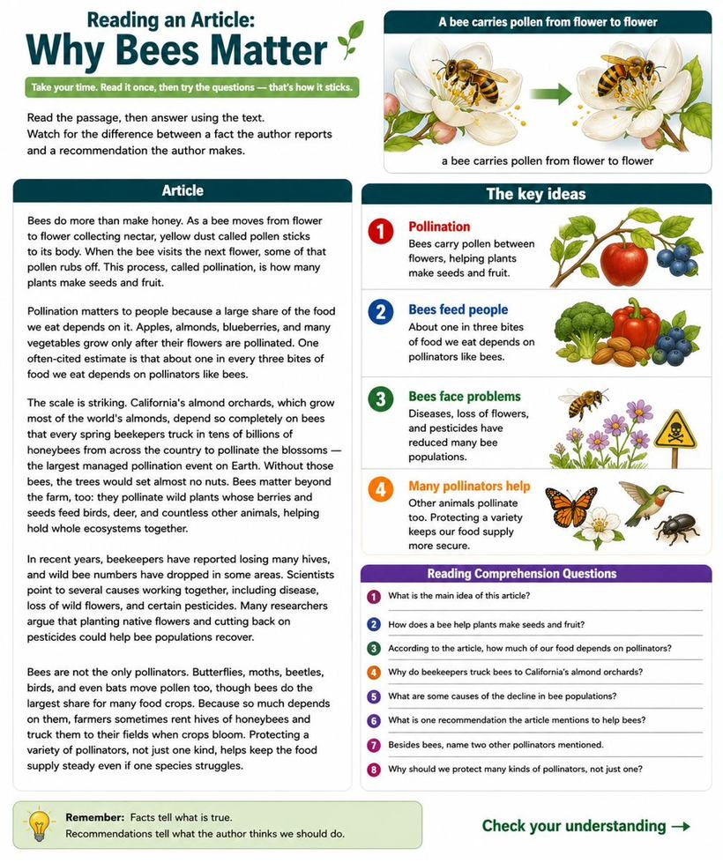
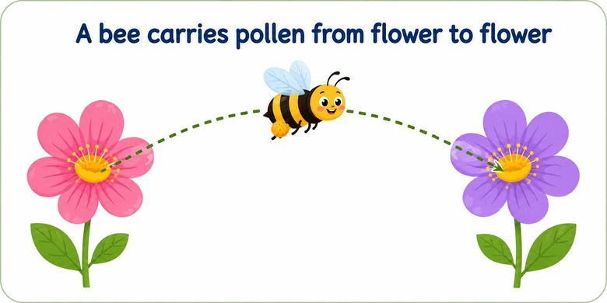
Questions
1. What is the main idea of the passage?
A. Bees make honey
B. Bees are important pollinators, and their numbers are dropping ✓
C. Flowers need nectar
D. Pesticides are useful
Answer: B. The passage is mostly about why bees matter as pollinators and the fact that they are declining.
2. According to the passage, what is pollination?
A. Bees making honey
B. Pollen moving from flower to flower so plants make seeds and fruit ✓
C. Flowers producing nectar
D. Bees losing their hives
Answer: B. The passage defines pollination as pollen carried between flowers, which lets plants make seeds and fruit.
3. Based on the passage, if bees disappeared, we would most likely expect:
A. More honey
B. Less of foods like apples and almonds ✓
C. More wild flowers
D. Fewer pesticides
Answer: B. The passage says crops like apples and almonds grow only after pollination, so losing bees would mean less of those foods — a fair inference.
4. The passage uses 'about one in every three bites of food' to show:
A. How much honey bees make
B. How much of our food depends on pollinators ✓
C. How many bees exist
D. How fast bees fly
Answer: B. That figure is given to show how large a share of our food depends on pollinators like bees.
5. According to the passage, why are billions of honeybees trucked into California's almond orchards each spring?
A. To make honey for sale
B. Because the almond trees depend on bees to pollinate their blossoms ✓
C. To protect the trees from pests
D. To collect water for the trees
Answer: B. The passage explains the orchards depend so completely on bees that beekeepers bring in billions to pollinate the blossoms, or the trees set almost no nuts.
6. Beyond farms, how else does the passage say bees are important?
A. They clean rivers
B. They pollinate wild plants that feed birds, deer, and other animals ✓
C. They control the weather
D. They build the soil
Answer: B. The passage says bees pollinate wild plants whose berries and seeds feed other animals, helping hold ecosystems together.

Reading an Article: Cells, the Building Blocks of Life
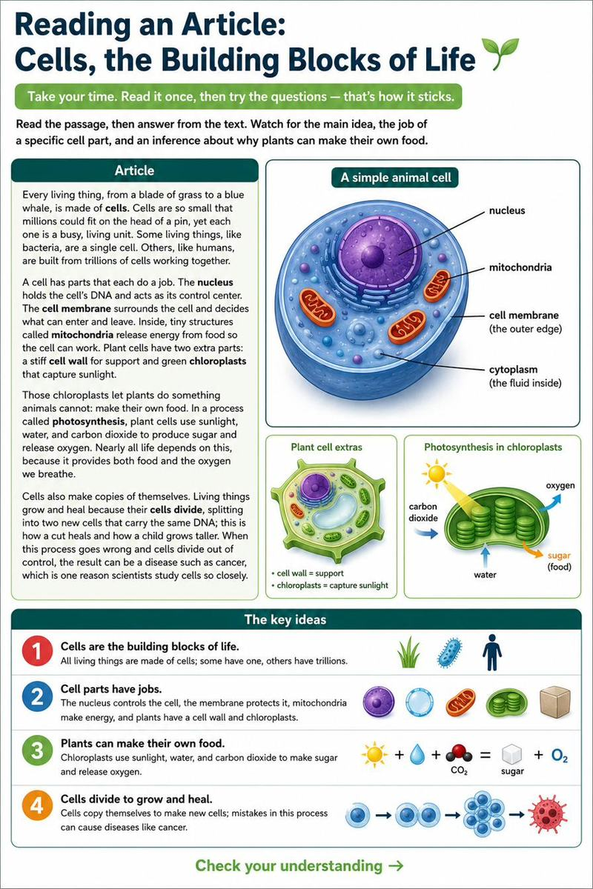
Questions
1. What is the main idea of the passage?
A. Bacteria are tiny
B. All living things are made of cells, which carry out life's jobs ✓
C. Plants are green
D. Humans have trillions of cells
Answer: B. The passage as a whole is about cells being the basic units of life and what they do.
2. According to the passage, what is the job of the nucleus?
A. To release energy
B. To hold the DNA and control the cell ✓
C. To let things in and out
D. To capture sunlight
Answer: B. The passage says the nucleus holds the cell's DNA and acts as its control center.
3. In the passage, 'photosynthesis' is the process by which:
A. Cells release energy from food
B. Plants make food from sunlight, water, and carbon dioxide ✓
C. DNA is copied
D. Water enters the cell
Answer: B. The passage defines photosynthesis as plant cells using sunlight, water, and carbon dioxide to make sugar and oxygen.
4. Based on the passage, plants can make their own food but animals cannot because plants have:
A. A nucleus
B. Mitochondria
C. Chloroplasts ✓
D. A cell membrane
Answer: C. The passage says chloroplasts let plants do what animals cannot — make food from sunlight.

Reading an Article: How the Body Uses Food
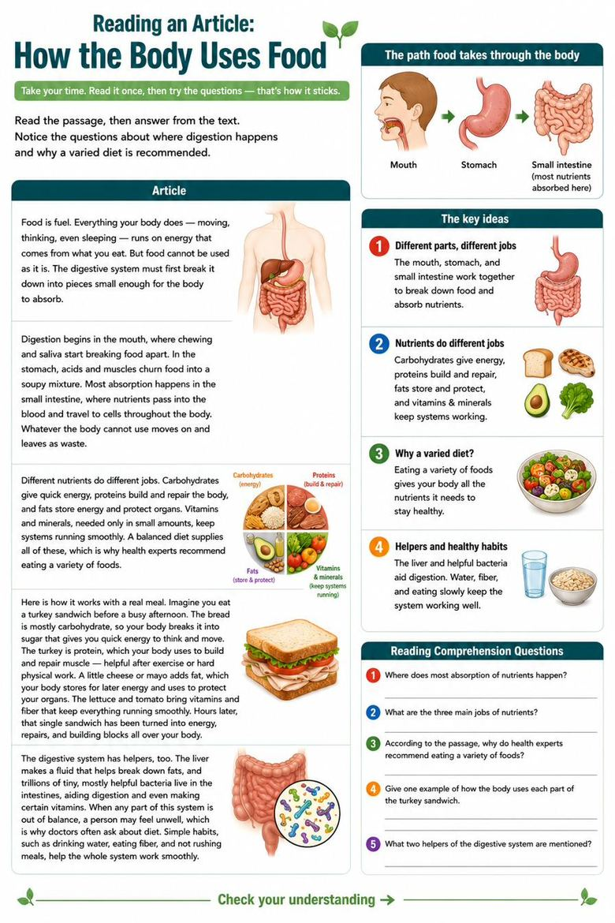
Questions
1. What is the main idea of the passage?
A. Chewing is important
B. How the body breaks down food and uses its nutrients ✓
C. The stomach has acids
D. Waste leaves the body
Answer: B. The passage is mostly about how the digestive system breaks down food so the body can use it.
2. According to the passage, where does most absorption of nutrients happen?
A. The mouth
B. The stomach
C. The small intestine ✓
D. The blood
Answer: C. The passage states most absorption happens in the small intestine, where nutrients pass into the blood.
3. According to the passage, which nutrient mainly builds and repairs the body?
A. Carbohydrates
B. Proteins ✓
C. Fats
D. Vitamins
Answer: B. The passage says proteins build and repair the body.
4. Based on the passage, why do health experts recommend eating a variety of foods?
A. Variety tastes better
B. Different nutrients do different jobs the body needs ✓
C. It is cheaper
D. It speeds up digestion
Answer: B. Because carbohydrates, proteins, fats, vitamins, and minerals each do different jobs, a variety supplies them all — a fair inference.
5. According to the passage, digestion begins in the:
A. Stomach
B. Small intestine
C. Mouth ✓
D. Blood
Answer: C. The passage says digestion begins in the mouth with chewing and saliva.
6. You eat a bowl of oatmeal before a long walk. Which type of nutrient in the oatmeal gives you quick energy?
A. Protein
B. Carbohydrates ✓
C. Fat
D. Water
Answer: B. The passage says carbohydrates give quick energy — exactly what you want before a walk.
7. After lifting weights, an athlete eats eggs and chicken. Which nutrient in that food mainly helps build and repair muscle?
A. Fat
B. Protein ✓
C. Sugar
D. Vitamins
Answer: B. The passage says proteins build and repair the body, so eggs and chicken help rebuild muscle after exercise.

Reading an Article: Genes and Heredity
Questions
1. What is the main idea of the passage?
A. Everyone has DNA
B. How traits are passed from parents to children through genes ✓
C. Blue eyes are rare
D. Punnett squares are hard
Answer: B. The passage is mostly about how traits are inherited through genes.
2. According to the passage, traits are carried in a molecule called:
A. Protein
B. DNA ✓
C. An allele
D. A Punnett square
Answer: B. The passage says genes are instructions carried in a molecule called DNA.
3. In the passage, a 'dominant' allele is one that:
A. Only shows with two copies
B. Shows up whenever it is present ✓
C. Never shows up
D. Is carried only by fathers
Answer: B. The passage defines a dominant allele as one that shows up whenever it is present.
4. Based on the passage, two brown-eyed parents can have a blue-eyed child because:
A. Blue eyes are dominant
B. Each parent carried a hidden recessive allele for blue eyes ✓
C. The child has no genes from them
D. Eye color is random
Answer: B. The passage explains both parents carried a hidden recessive blue-eye allele — a direct inference.

Reading an Article: Natural Selection
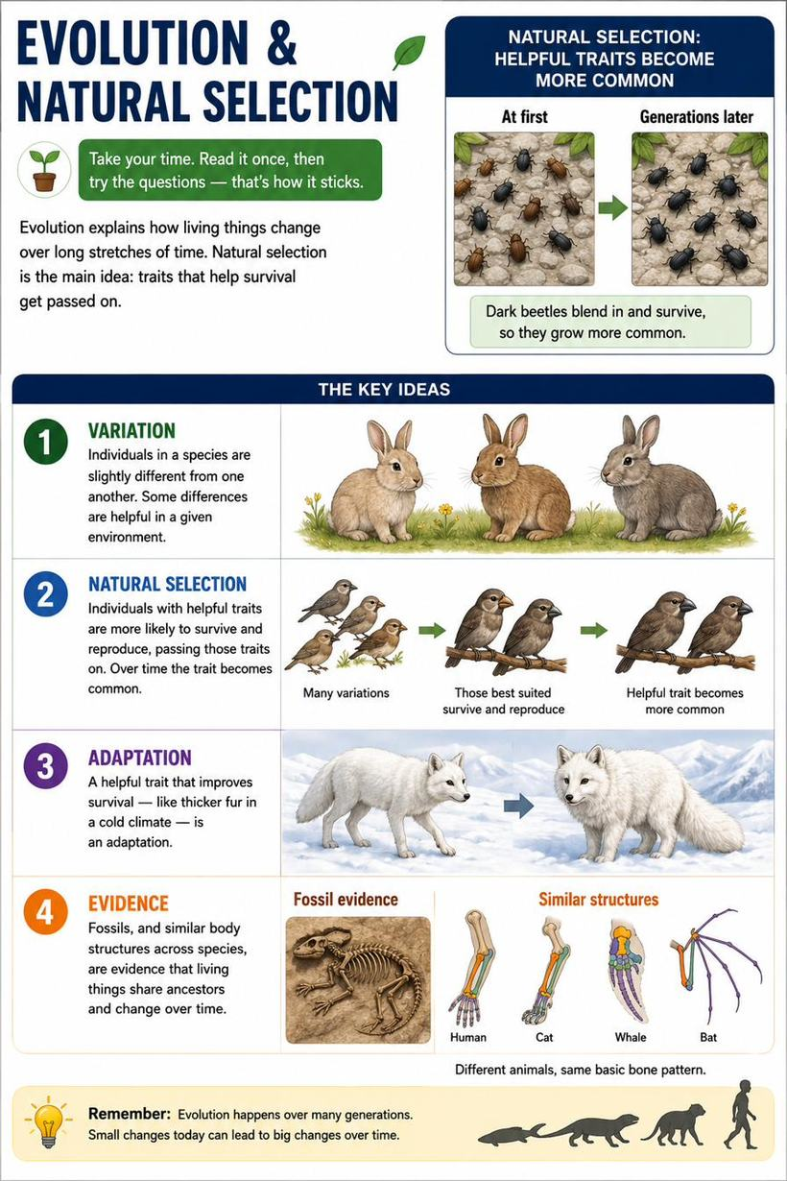
Questions
1. What is the main idea of the passage?
A. Beetles are dark
B. How species change over time through natural selection ✓
C. Birds eat beetles
D. Fossils are old
Answer: B. The passage is mostly about how helpful traits spread through natural selection, driving evolution.
2. In the passage, 'variations' are:
A. Types of birds
B. Small differences among individuals of a species ✓
C. Changes in the weather
D. Kinds of trees
Answer: B. The passage defines variations as the small differences among individuals within a species.
3. Based on the passage, why did the beetle group become mostly dark over time?
A. Dark beetles laid more eggs by chance
B. Birds ate the easy-to-see light beetles, so dark ones survived and reproduced ✓
C. The bark turned dark
D. Dark beetles were larger
Answer: B. The passage explains birds ate the visible light beetles, so the surviving dark beetles passed on their color — a direct inference.
4. In the passage, a trait that improves survival in an environment is called:
A. A variation
B. An adaptation ✓
C. A fossil
D. A species
Answer: B. The passage defines an adaptation as a trait that improves survival in a certain environment.

