Physical Science Study Book
Diagrams, Questions & Answers
GED & HiSET Science · GRDM Publishing, LLC · gingertheteacher.com
Study the diagram, then answer the questions. Correct answers are marked in bold.

Matter & Its Properties
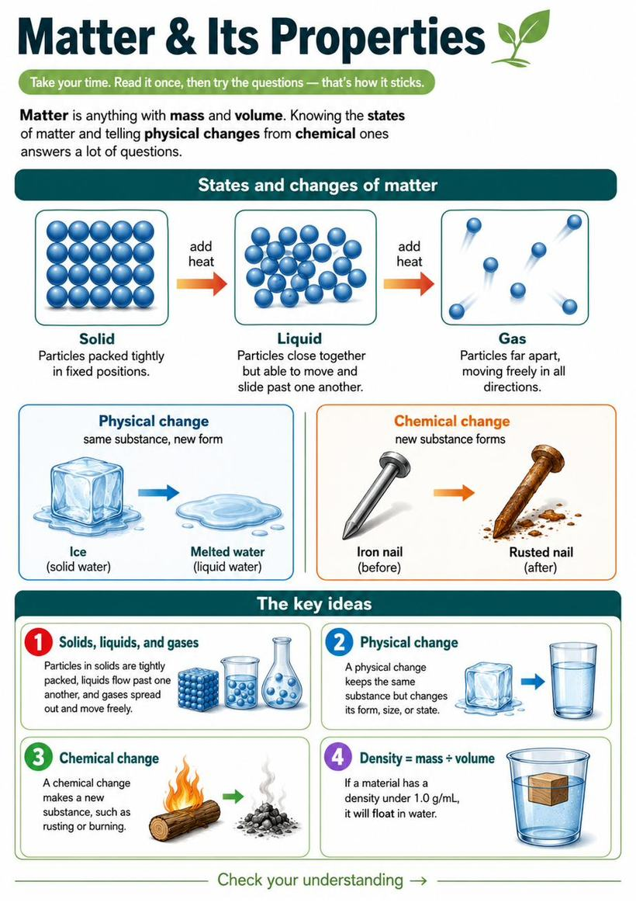
Questions
1. What is the main idea of this passage?
A. Ice is cold
B. The states of matter and the two kinds of changes ✓
C. Gases are invisible
D. Iron rusts slowly
Answer: B. The passage covers solids, liquids, and gases plus physical versus chemical changes.
2. According to the passage, ice melting is an example of a:
A. Chemical change
B. Physical change ✓
C. New substance forming
D. Gas
Answer: B. The passage gives ice melting as a physical change — the same material in a new form.
3. Which of the following is a chemical change?
A. Ice melting
B. Iron rusting ✓
C. Water boiling
D. Tearing paper
Answer: B. Rusting forms a new substance (iron oxide). The others only change form or state.
4. Which material would sink in water?
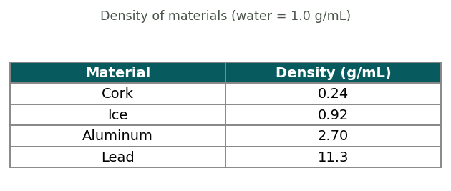
A. Cork
B. Ice
C. Aluminum ✓
D. None
Answer: C. Anything denser than 1.0 g/mL sinks. Aluminum (2.70) sinks; cork and ice float.

Atoms & Chemical Reactions
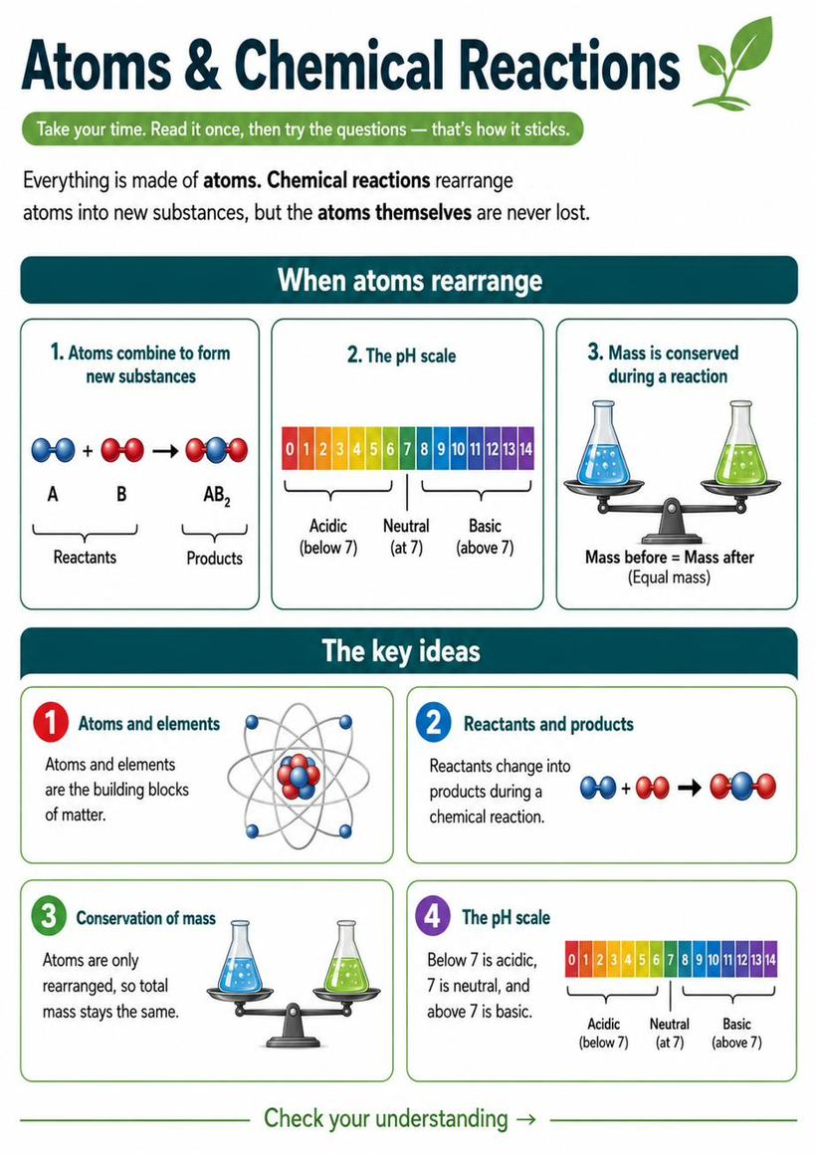
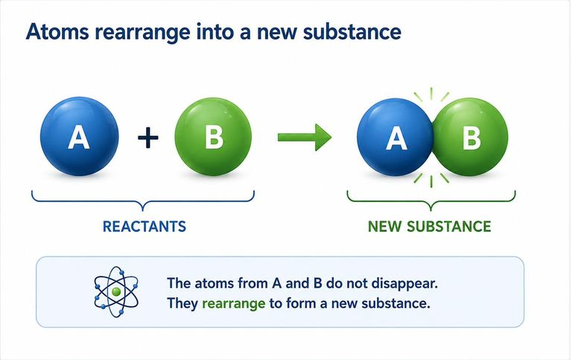
Questions
1. What is the main idea of this passage?
A. Water is a compound
B. Atoms build all matter, and mass is conserved in reactions ✓
C. Gold is valuable
D. Reactions happen fast
Answer: B. The passage is about atoms forming matter and the conservation of mass.
2. In the passage, an 'element' is:
A. A mixture of substances
B. A substance made of just one kind of atom ✓
C. A kind of reaction
D. A drop of water
Answer: B. The passage defines an element as a substance made of one kind of atom.
3. In a sealed jar, 10 g of reactants react completely. What is the total mass of the products?
A. Less than 10 g
B. Exactly 10 g ✓
C. More than 10 g
D. It cannot be known
Answer: B. By conservation of mass, atoms aren't lost, so the products also total 10 g.
4. A substance with a pH of 3 is:
A. A base
B. Neutral
C. An acid ✓
D. A metal
Answer: C. A pH below 7 is acidic, so pH 3 is an acid.

Chemical Equations
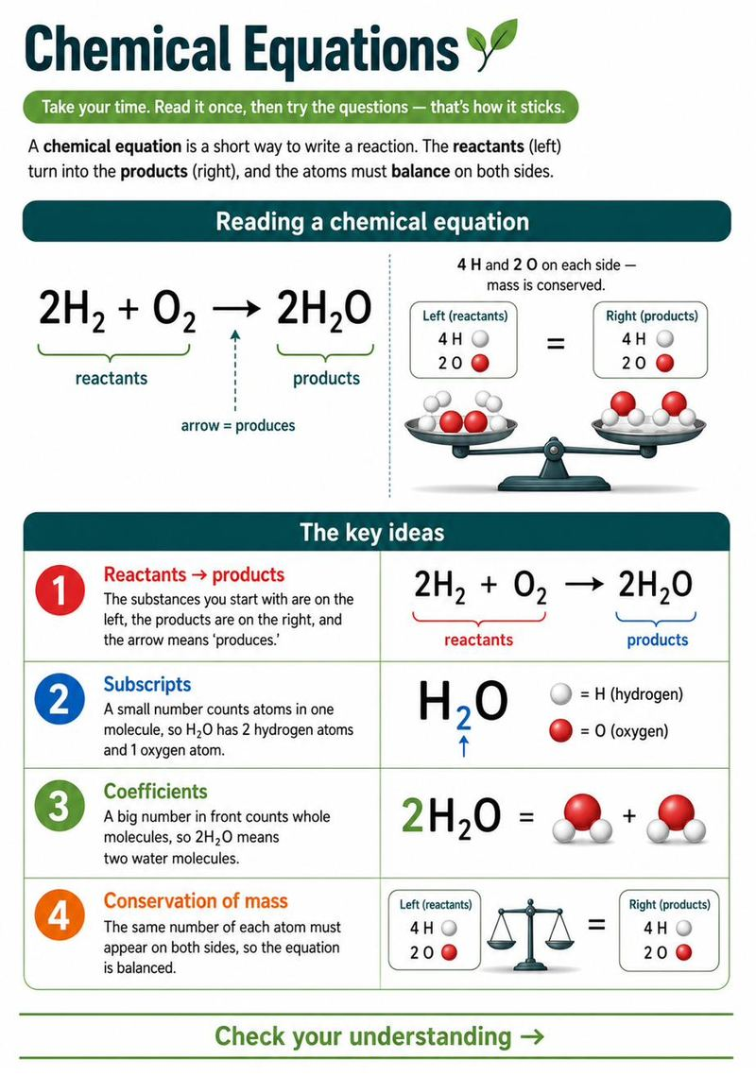
Questions
1. What is the main idea of this passage?
A. Arrows are important
B. How to read a chemical equation ✓
C. Water is H₂O
D. Atoms are tiny
Answer: B. The passage explains how to read an equation: reactants, products, subscripts, coefficients, and balance.
2. According to the passage, why must an equation be balanced?
A. To look neat
B. Because atoms are never created or destroyed ✓
C. Because of the arrow
D. To use bigger numbers
Answer: B. The passage says atoms are never created or destroyed, so each kind of atom must be equal on both sides.
3. In the equation 2H₂ + O₂ → 2H₂O, which are the reactants?
A. 2H₂O
B. 2H₂ and O₂ ✓
C. Only O₂
D. The arrow
Answer: B. Reactants are the substances on the LEFT of the arrow: 2H₂ and O₂.
4. What does the arrow (→) in a chemical equation mean?
A. Equals zero
B. 'Produces' or 'yields' ✓
C. Subtract
D. Divide
Answer: B. The arrow shows that the reactants produce (yield) the products.
5. In the formula H₂O, how many hydrogen atoms are there?
A. 1
B. 2 ✓
C. 3
D. 0
Answer: B. The subscript 2 right after the H means 2 hydrogen atoms.
6. In 2H₂O, how many water molecules are shown?
A. 1
B. 2 ✓
C. 4
D. 6
Answer: B. The coefficient 2 in front of the formula means two whole water molecules.
7. Why must a chemical equation be balanced — the same atoms on both sides?
A. To look neat
B. Because atoms are never created or destroyed ✓
C. To make the numbers bigger
D. Because of gravity
Answer: B. Matter is conserved: atoms are only rearranged, so each kind of atom must be equal on both sides.
8. How many oxygen atoms are on the LEFT side of 2H₂ + O₂ → 2H₂O?
A. 1
B. 2 ✓
C. 4
D. 0
Answer: B. O₂ contains 2 oxygen atoms, and there is no other oxygen on the left, so 2.
9. In C + O₂ → CO₂, how many oxygen atoms are on each side?
A. 1
B. 2 ✓
C. 3
D. 4
Answer: B. O₂ has 2 oxygen atoms on the left, and CO₂ has 2 oxygen atoms on the right — balanced.
10. In the formula CH₄, how many hydrogen atoms are there?
A. 1
B. 2
C. 4 ✓
D. 6
Answer: C. The subscript 4 after the H means 4 hydrogen atoms.
11. In 2NaCl, how many chlorine (Cl) atoms are shown in all?
A. 1
B. 2 ✓
C. 3
D. 4
Answer: B. The coefficient 2 means two NaCl units, each with 1 Cl, so 2 chlorine atoms.
12. In CH₄ + 2O₂ → CO₂ + 2H₂O, which substance is a PRODUCT?
A. CH₄
B. O₂
C. CO₂ ✓
D. None of these
Answer: C. Products are on the right of the arrow: CO₂ and 2H₂O.

Forces & Motion
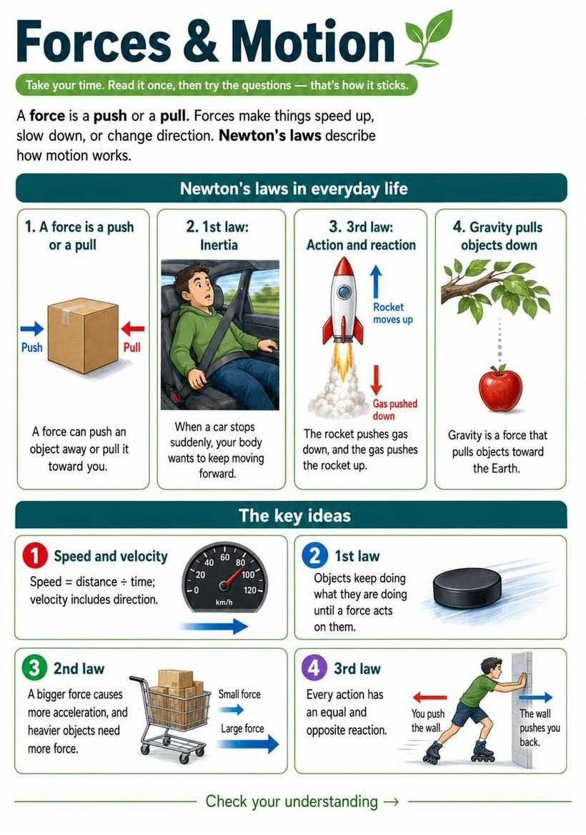
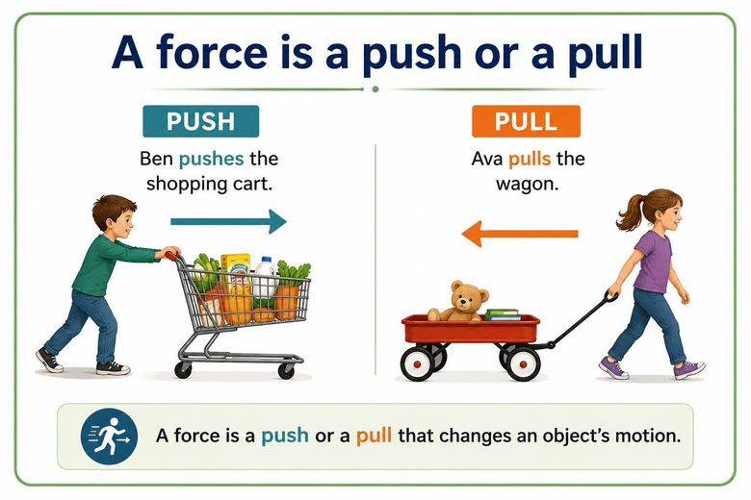
Questions
1. An object at rest stays at rest unless a force acts on it. This idea is called:
A. Gravity
B. Inertia ✓
C. Friction
D. Energy
Answer: B. Inertia is an object's tendency to keep doing what it's doing until a force changes it.
2. A car travels 150 miles in 3 hours. What is its average speed in miles per hour? (Type the number)
Answer: 50. Speed = distance / time = 150 / 3 = 50 mph.

Energy
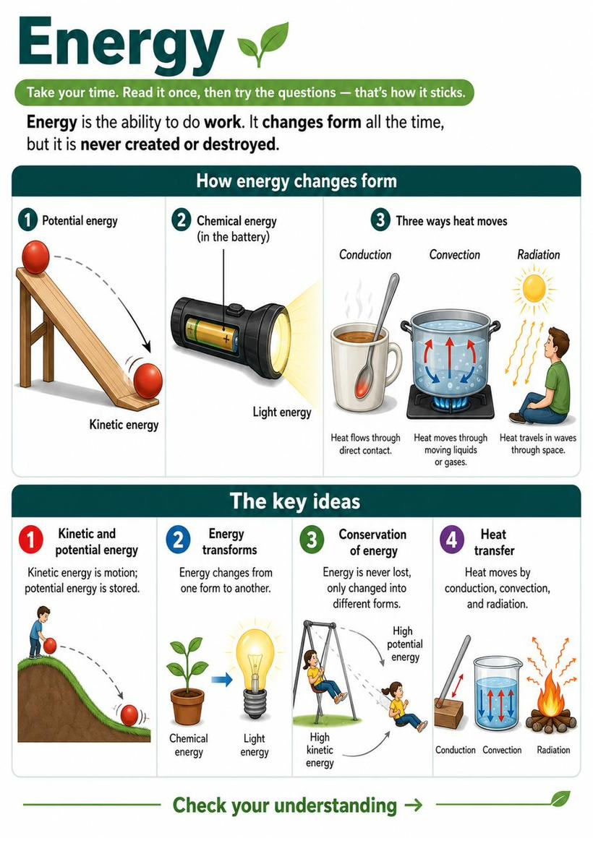
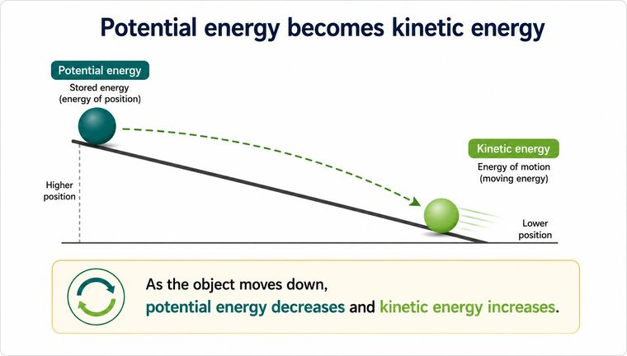
Questions
1. Which is an example of stored (potential) energy?
A. A car driving
B. A book on a high shelf ✓
C. A rolling ball
D. A spinning fan
Answer: B. A book on a high shelf has stored energy due to its position; if it falls, that becomes motion. The others are already moving (kinetic).
2. When you rub your hands together, they warm up. Friction turns motion energy into:
A. Light
B. Sound
C. Thermal (heat) energy ✓
D. Chemical energy
Answer: C. Friction converts motion into thermal energy, warming the surfaces.

Waves, Light & Electricity
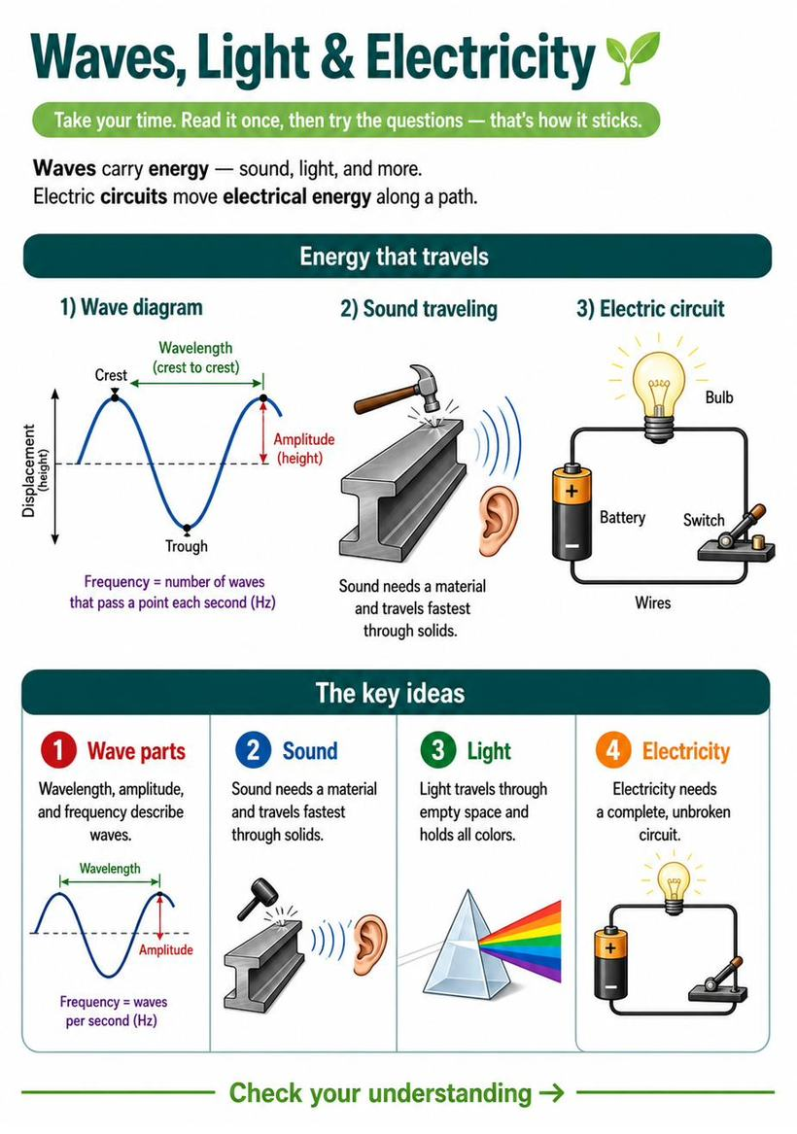
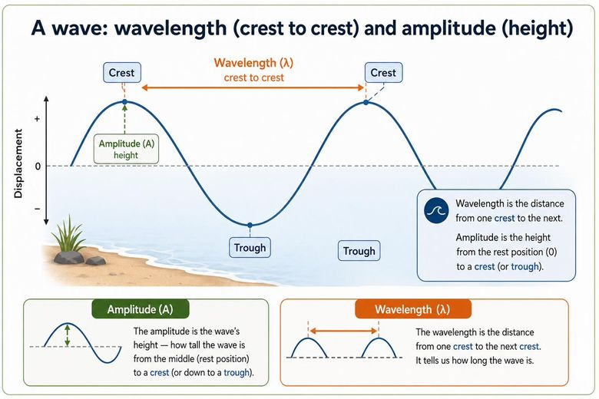
Questions
1. On the wave shown, the distance labeled X (crest to crest) is the wave's:
A. Amplitude
B. Wavelength ✓
C. Frequency
D. Speed
Answer: B. The distance from one crest to the next is the wavelength. The height (Y) is the amplitude.
2. Sound travels fastest through which material?
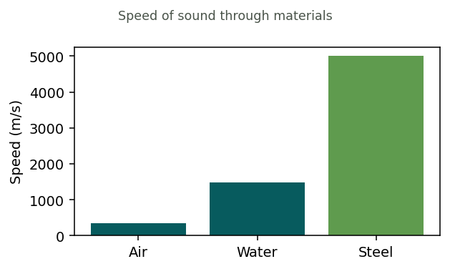
A. Air
B. Water
C. Steel ✓
D. Equal
Answer: C. Steel is the tallest bar. Sound travels fastest through solids, slowest through gases.

Magnetism
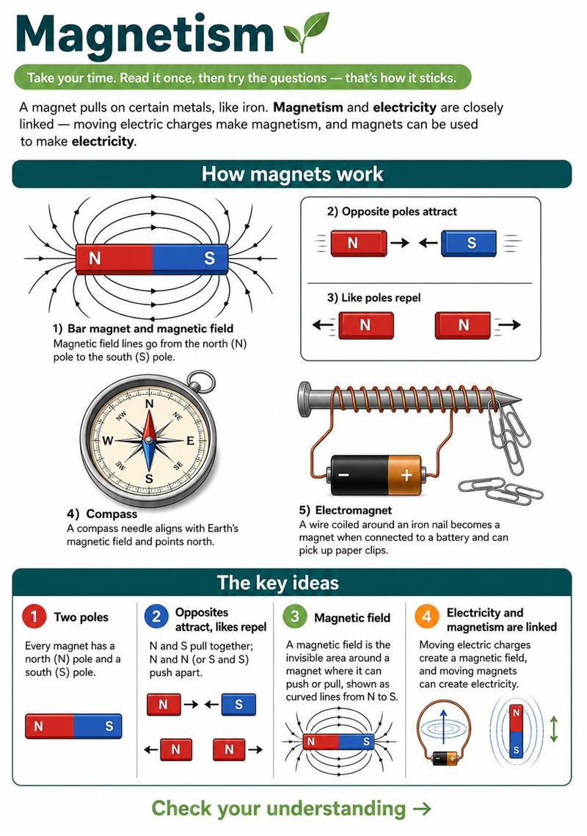
Questions
1. Every magnet has how many poles?
A. One
B. Two ✓
C. Three
D. None
Answer: B. Every magnet has two poles — a north (N) and a south (S).
2. What happens when you bring two NORTH poles close together?
A. They attract (pull together)
B. They repel (push apart) ✓
C. Nothing happens
D. They melt
Answer: B. Like poles repel. Two norths (or two souths) push apart; opposite poles attract.
3. The invisible area around a magnet where it can push or pull is called the:
A. Magnetic field ✓
B. Circuit
C. Current
D. Pole
Answer: A. The magnetic field is the area around a magnet where its force can act.
4. An electromagnet is made by:
A. Rubbing two magnets together
B. Running electric current through a coil of wire ✓
C. Heating iron
D. Freezing a magnet
Answer: B. Moving electric charges (current) through a coiled wire create a magnetic field — an electromagnet.

Reading an Article: Renewable Energy
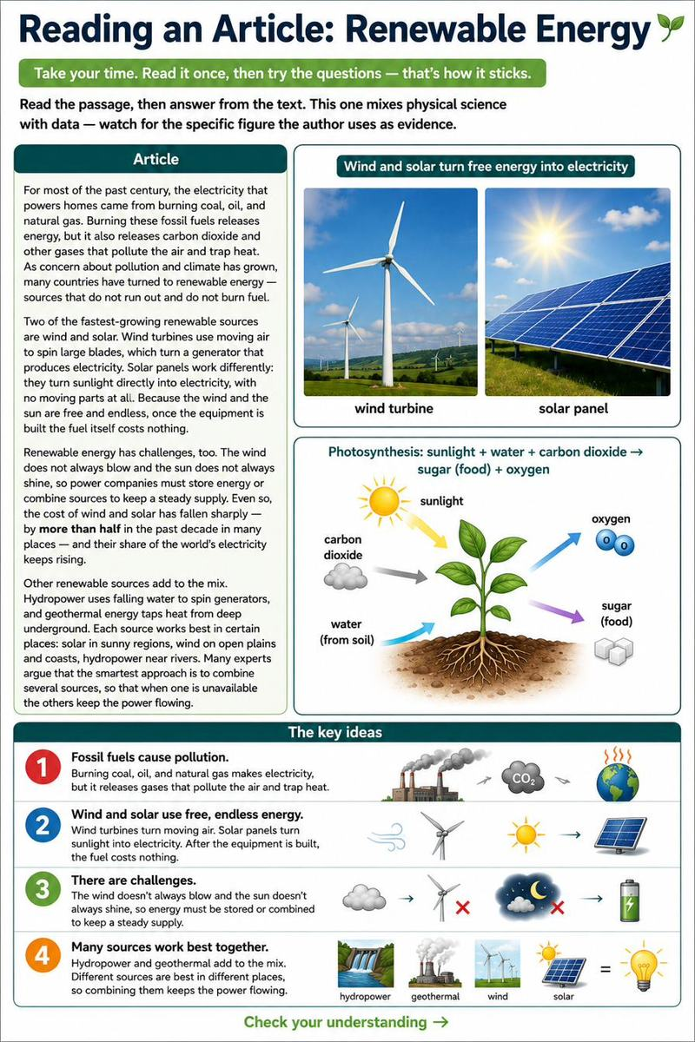
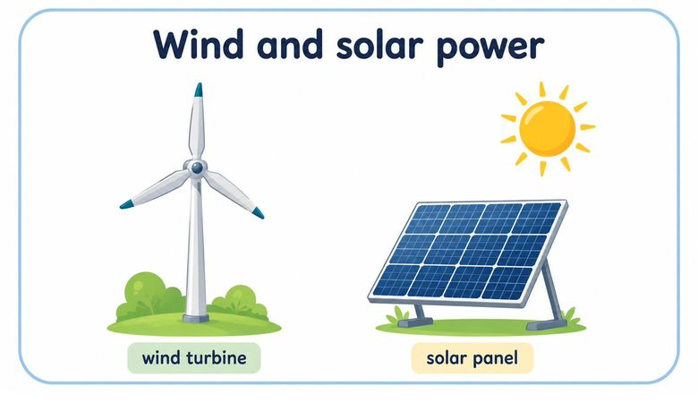
Questions
1. What is the main idea of the passage?
A. Fossil fuels are cheap
B. Wind and solar are growing as clean alternatives to fossil fuels ✓
C. Solar panels have moving parts
D. The wind always blows
Answer: B. The passage is mostly about renewable energy (wind and solar) replacing polluting fossil fuels.
2. According to the passage, how does a wind turbine make electricity?
A. It burns fuel
B. Moving air spins blades that turn a generator ✓
C. Sunlight hits a panel
D. It stores heat
Answer: B. The passage says wind turbines use moving air to spin blades, which turn a generator.
3. In the passage, 'renewable energy' means sources that:
A. Burn cleanly
B. Do not run out and do not burn fuel ✓
C. Are always available
D. Cost nothing to build
Answer: B. The passage defines renewable energy as sources that do not run out and do not burn fuel.
4. Based on the passage, a real challenge for wind and solar is that:
A. They cost too much fuel
B. The wind and sun are not always available ✓
C. They pollute the air
D. They cannot make electricity
Answer: B. The passage explains the wind doesn't always blow and the sun doesn't always shine, so power must be stored or combined — a fair inference.

Reading an Article: Sound and How We Hear
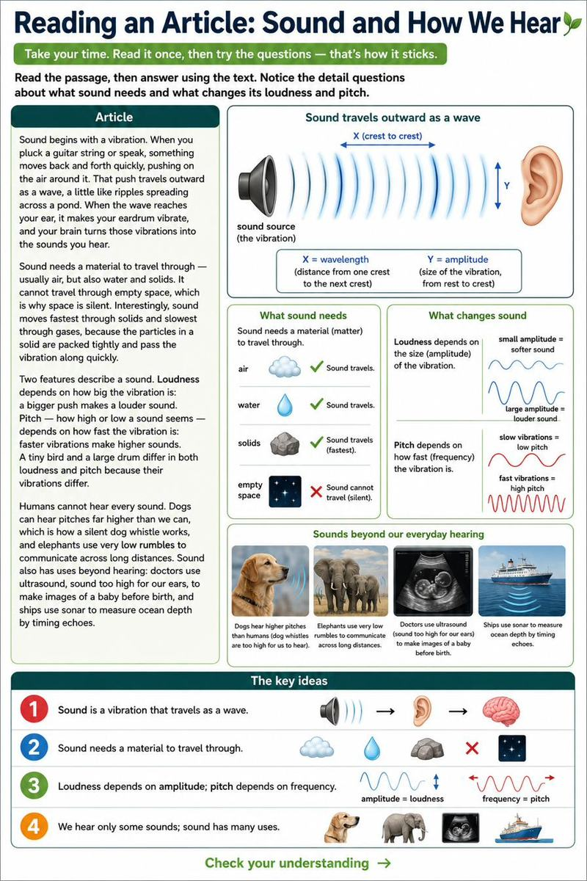
Questions
1. What is the main idea of the passage?
A. Guitars are loud
B. How sound is made, travels, and is described ✓
C. Space is silent
D. Ears are complicated
Answer: B. The passage is mostly about how sound starts, moves, and what features describe it.
2. According to the passage, what does sound need in order to travel?
A. Bright light
B. A material such as air, water, or a solid ✓
C. Empty space
D. Electricity
Answer: B. The passage states sound needs a material to travel through and cannot cross empty space.
3. The passage says sound travels FASTEST through:
A. Gases
B. Liquids
C. Solids ✓
D. Empty space
Answer: C. The passage explains sound moves fastest through solids because their particles are packed tightly.
4. Based on the passage, why is space silent?
A. Space is too cold
B. There is no material for sound to travel through ✓
C. Sound is too weak
D. No one is listening
Answer: B. Since sound needs a material and space is empty, sound cannot travel there — a direct inference.

Reading an Article: Forces and Motion
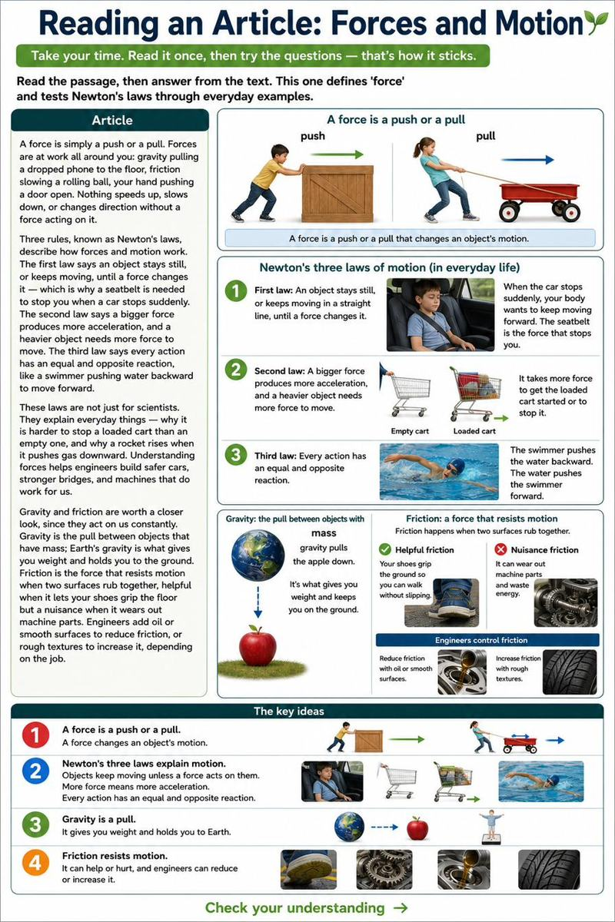
Questions
1. What is the main idea of the passage?
A. Cars are dangerous
B. How forces and Newton's laws explain motion ✓
C. Rockets are fast
D. Doors are heavy
Answer: B. The passage is mostly about forces and the three laws that describe how motion works.
2. In the passage, a 'force' is defined as:
A. A kind of energy
B. A push or a pull ✓
C. A moving object
D. A type of speed
Answer: B. The passage says a force is simply a push or a pull.
3. According to the passage, why do you need a seatbelt when a car stops suddenly?
A. Cars are heavy
B. A moving object keeps moving until a force stops it (Newton's first law) ✓
C. Seatbelts add speed
D. Gravity pulls you down
Answer: B. The passage uses the seatbelt to illustrate the first law: a moving object keeps moving until a force changes it.
4. Based on the passage, why is it harder to stop a loaded cart than an empty one?
A. The loaded cart is colder
B. A heavier object needs more force to change its motion ✓
C. Empty carts have no wheels
D. Loaded carts move faster on their own
Answer: B. By the second law, a heavier object needs more force — so stopping the heavier cart takes more force. A direct inference.

Reading an Article: Chemical Changes
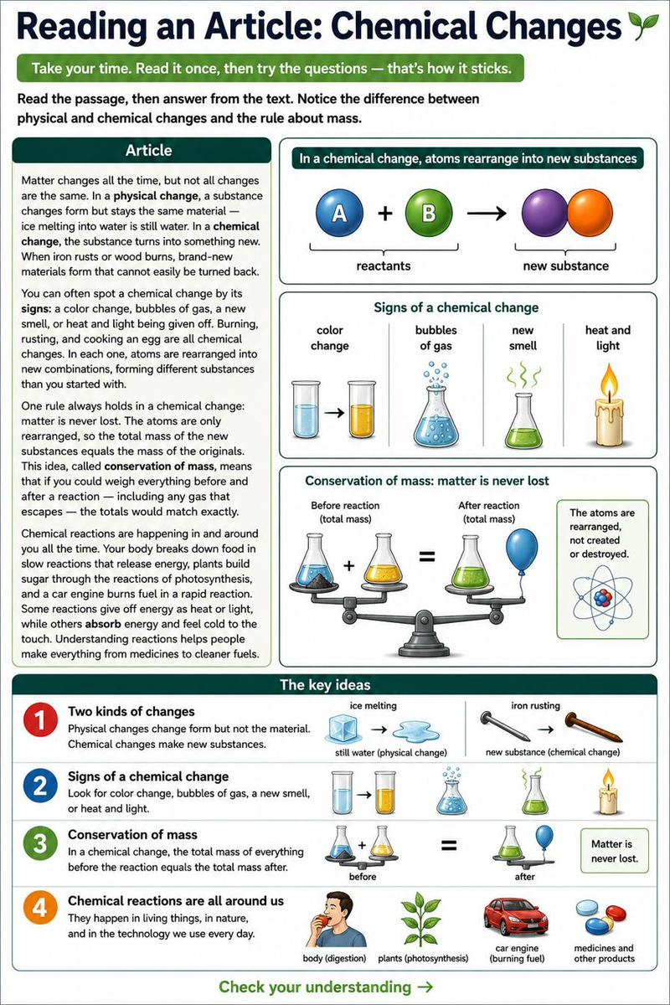
Questions
1. What is the main idea of the passage?
A. Ice is cold
B. The difference between physical and chemical changes, and that matter is conserved ✓
C. Eggs are food
D. Rust is red
Answer: B. The passage contrasts physical and chemical changes and explains conservation of mass.
2. According to the passage, which is an example of a PHYSICAL change?
A. Iron rusting
B. Wood burning
C. Ice melting into water ✓
D. An egg cooking
Answer: C. The passage gives ice melting as a physical change — it is still water, the same material.
3. According to the passage, which is a sign of a chemical change?
A. The object gets wet
B. A color change, gas bubbles, or heat and light given off ✓
C. The object moves
D. The object gets colder only
Answer: B. The passage lists color change, gas, new smell, and heat or light as signs of a chemical change.
4. Based on the passage, a nail rusting is a chemical change because:
A. The nail gets wet
B. A brand-new material forms that can't easily be turned back ✓
C. The nail changes shape
D. The nail gets colder
Answer: B. The passage says rusting forms a new material — the mark of a chemical change.

