Science Skills Study Book
Diagrams & Practice Questions — Student Edition
GED & HiSET Science · GRDM Publishing, LLC · gingertheteacher.com
Study the diagram, then circle the best answer for each question.
Name: _______________________________ Date: ______________

Reading Science & Finding Evidence
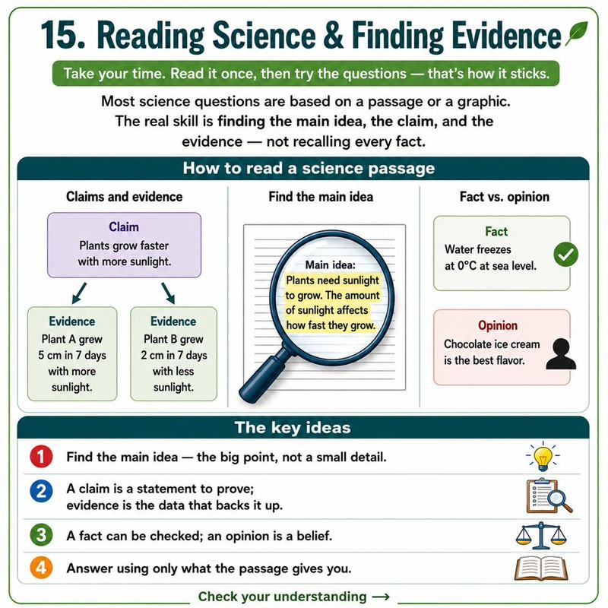
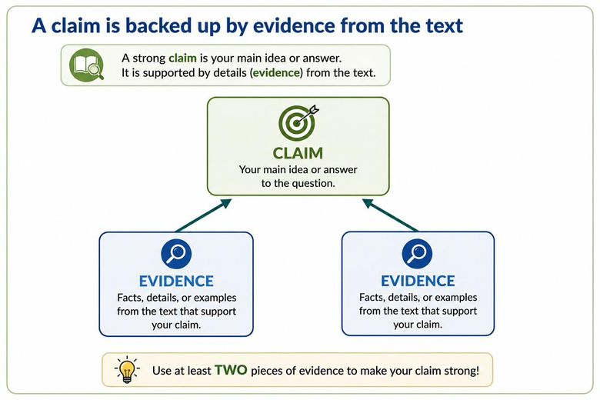
Questions
1. Which of these is a claim rather than evidence?
A. The plants grew 12 cm in two weeks
B. Fertilizer is the best way to grow tomatoes
C. The sample included 40 plants
D. The temperature stayed at 70°F
2. Read: 'The town added a bike lane. Afterward, bike commuting rose 30% and traffic accidents fell.' What is the main idea?
A. Bikes are expensive
B. The new bike lane had positive effects
C. Cars are dangerous
D. Everyone should bike

Designing & Interpreting Experiments
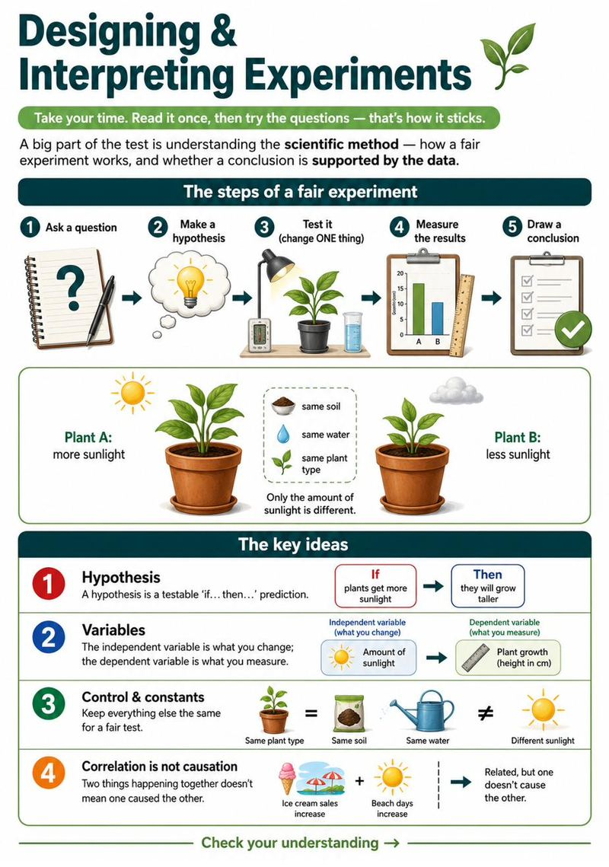
Questions
1. A student gives plants different amounts of water and measures their growth. What is the independent variable (the thing changed on purpose)?
A. The growth of the plants
B. The amount of water
C. The type of soil
D. The size of the pot
2. In a fair experiment, why should you keep everything the same except one variable?
A. To save time
B. So you know the change caused any difference
C. To use less equipment
D. To make it harder
3. Ice cream sales and sunburns both rise in summer. What is the best conclusion?
A. Ice cream causes sunburns
B. Sunburns cause ice cream sales
C. Both rise with hot, sunny weather
D. There is no reason
4. What is the FIRST step of the scientific method?
A. Draw a conclusion
B. Ask a question about something you observe
C. Measure the results
D. Change two things at once
5. In the scientific method, what do you do right after forming a hypothesis?
A. Publish the results
B. Test it with a fair experiment
C. Change the question
D. Throw out the data

Test Practice: Read the Material, Answer the Set
Questions
1. According to Table 1, how does the amount of sediment downstream compare with the amount above the beavers' pool?
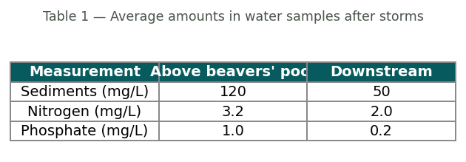
A. It is more than twice as high downstream
B. It is about the same
C. It is less than half as much downstream
D. The table does not show sediment
2. Based on the passage and the table, what is the most reasonable conclusion about the beavers' pool?
A. It adds sediment and nutrients to the water
B. It traps sediment and nutrients, so less flows downstream
C. It has no effect on the water
D. It only affects nitrogen
3. Beavers cut down mostly small trees close to the water. Which change to the habitat would MOST likely result?
A. Fewer trees shading the stream near the bank
B. More trees growing in the stream
C. The stream flowing uphill
D. No change at all
4. Which of these is a CLAIM rather than a measurement reported in the study?
A. Sediment above the pool averaged 120 mg/L
B. Nitrogen downstream averaged 2.0 mg/L
C. Beaver dams improve water quality downstream
D. Phosphate above the pool averaged 1.0 mg/L
5. On which surface did the ball roll the FARTHEST?
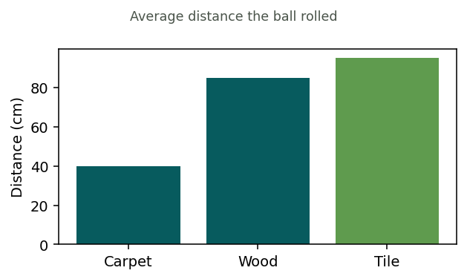
A. Carpet
B. Wood
C. Tile
D. They were equal
6. Which statement best explains why the ball rolled the shortest distance on carpet?
A. Carpet has more friction, which slows the ball
B. Carpet has no friction
C. The ball was heavier on carpet
D. Gravity is stronger on carpet
7. Why did the class release the ball from the same height every time?
A. To make the test look neat
B. So the only thing changing was the surface
C. To use less time
D. To make the ball heavier

