Science Math Study Book
Diagrams & Practice Questions — Student Edition
GED & HiSET Science · GRDM Publishing, LLC · gingertheteacher.com
Study the diagram, then circle the best answer for each question.
Name: _______________________________ Date: ______________

Reading Graphs & Tables
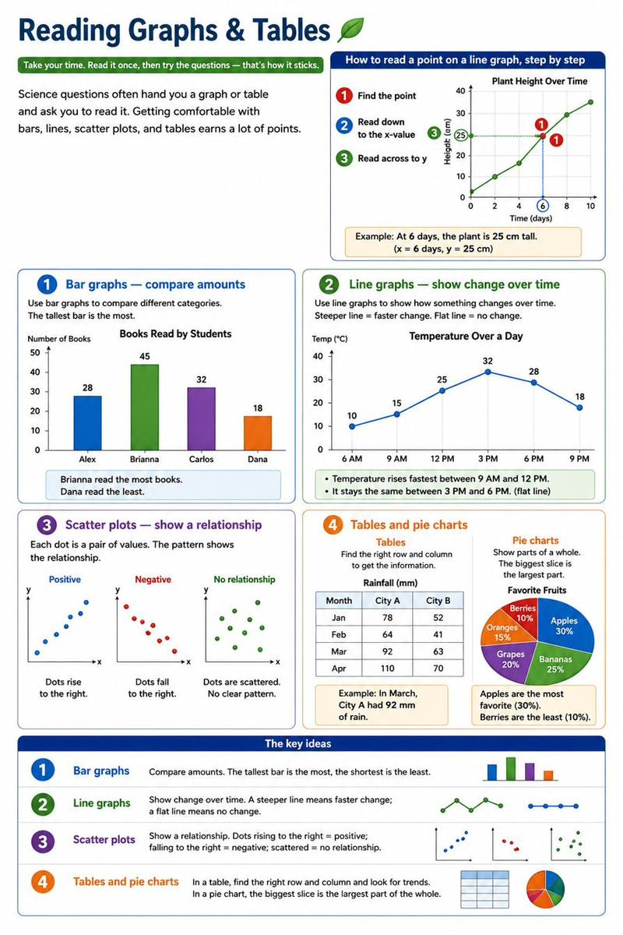
Questions
1. In this double bar graph, which city had more rain in February?
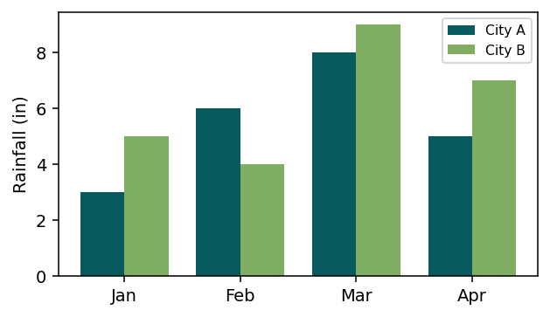
A. City A
B. City B
C. They were equal
D. Neither had rain
2. A double bar graph uses two colors so you can:
A. Make it prettier
B. Compare two groups side by side
C. Hide the numbers
D. Show a pie
3. In which month were the most books read?
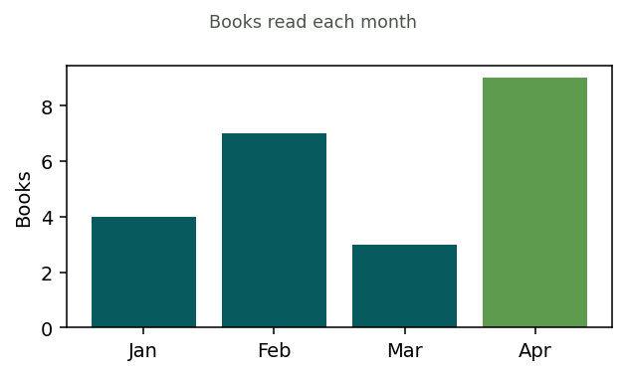
A. January
B. February
C. March
D. April
4. According to the table, which city had the LEAST rainfall?
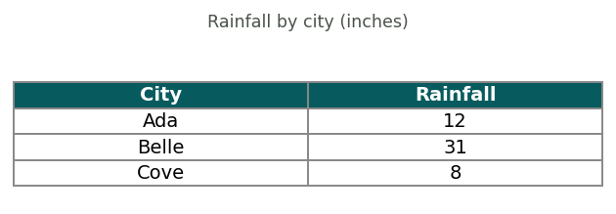
A. Ada
B. Belle
C. Cove
D. They are equal
5. Which animal was most common?
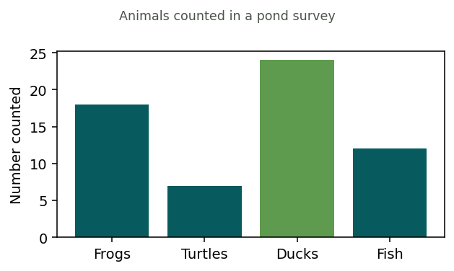
A. Frogs
B. Turtles
C. Ducks
D. Fish
6. What relationship does the scatter plot show?
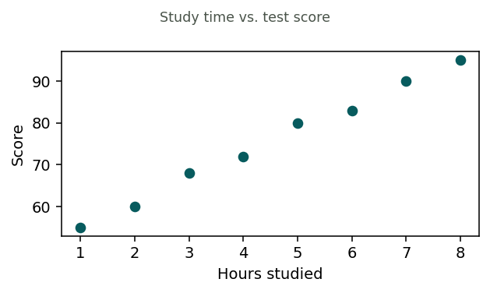
A. More study, lower scores
B. More study, higher scores
C. No relationship
D. Scores stay the same
7. During which period did the population grow fastest?
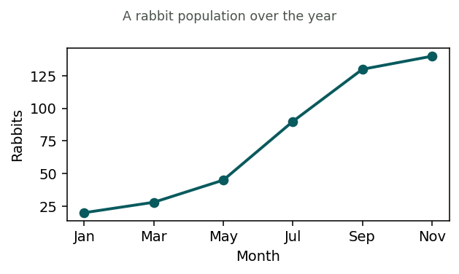
A. Jan to Mar
B. Mar to May
C. May to Jul
D. Sep to Nov

Data & Numbers in Science
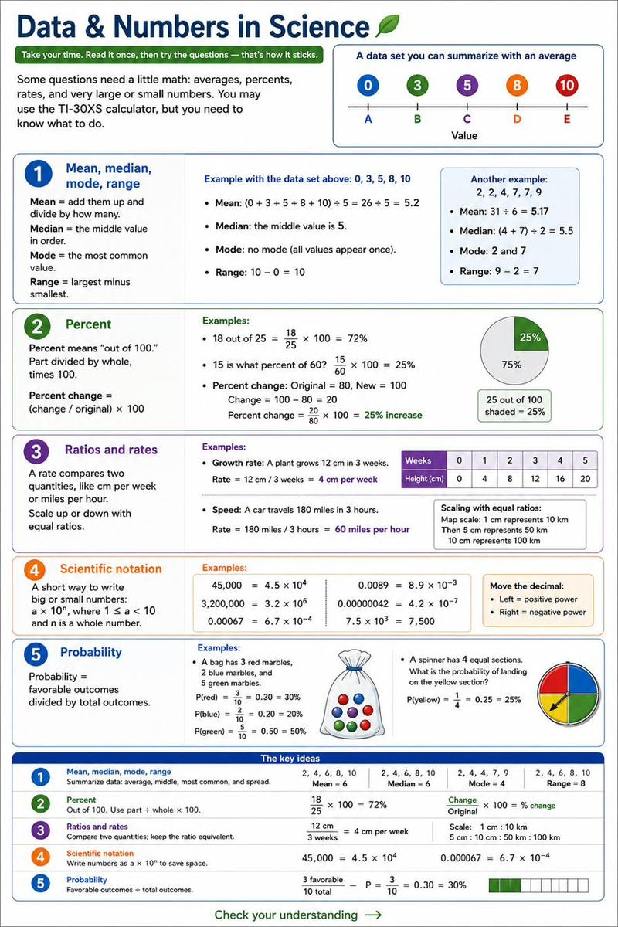
Questions
1. A plant grew from 10 cm to 16 cm. What was the percent increase?
A. 6%
B. 16%
C. 60%
D. 160%
2. What is the median of 3, 9, 4, 7, 5?
A. 4
B. 5
C. 7
D. 9
3. A car travels 120 miles in 2 hours. What is its rate (speed)?
A. 60 miles per hour
B. 120 miles per hour
C. 240 miles per hour
D. 2 miles per hour
4. What is the mean (average) height? (Type the number)
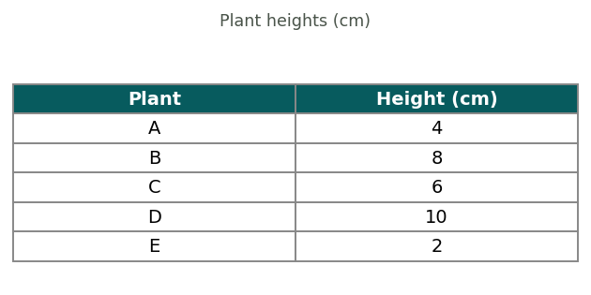
Answer: ______________________________
5. Find the median of: 3, 7, 2, 9, 5. (Type the number)
Answer: ______________________________
6. What is the range of: 12, 4, 9, 4, 15? (Type the number)
Answer: ______________________________
7. In a sample of 200 cells, 30 are dividing. What percent are dividing? (Type the number, no % sign)
Answer: ______________________________
8. Which is 45,000 in scientific notation?
A. 4.5 × 10³
B. 45 × 10³
C. 4.5 × 10⁴
D. 4.5 × 10⁵
9. Which is 0.0007 written in scientific notation?
A. 7 × 10⁴
B. 7 × 10⁻³
C. 7 × 10⁻⁴
D. 0.7 × 10³
10. What is 3 × 10⁵ written out as a regular number?
A. 350
B. 3,000
C. 30,000
D. 300,000

Reading Graphs: Complete the Passage

How to Read Charts & Graphs
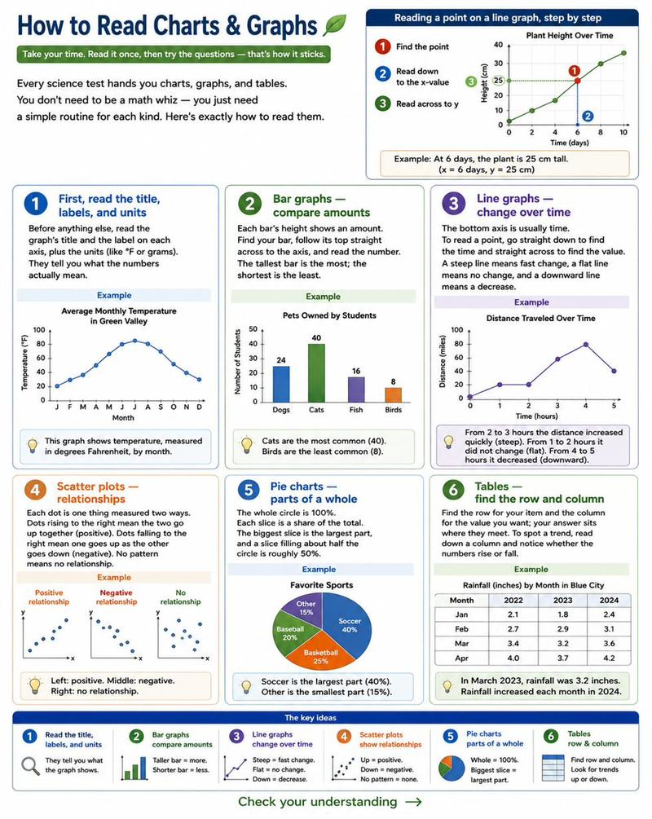
Questions
1. According to the passage, what should you read FIRST on a graph?
A. The color
B. The title and the axis labels
C. The biggest bar
D. The bottom corner
2. Why does the passage warn you to check the scale?
A. Scales are always wrong
B. A graph can look dramatic even when the real change is small
C. Bigger scales are better
D. The scale never matters
3. During which hour did the store have the MOST visitors?
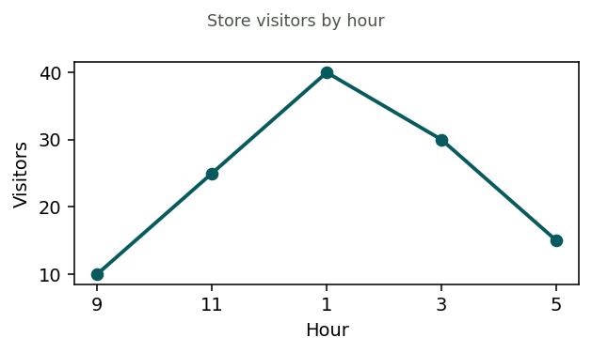
A. 9
B. 11
C. 1 o'clock
D. 5
4. What happens to the number of visitors after 1 o'clock?
A. It keeps rising
B. It stays the same
C. It falls
D. It doubles
5. In this monthly budget, which is the largest share?
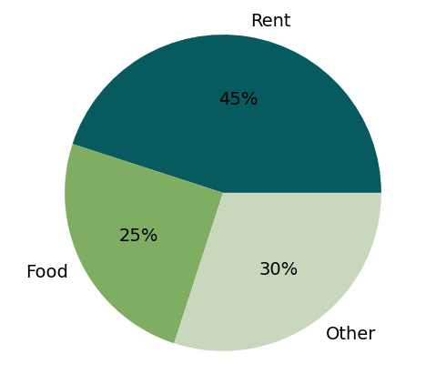
A. Rent
B. Food
C. Other
D. They are equal
6. According to the table, who had the highest score?
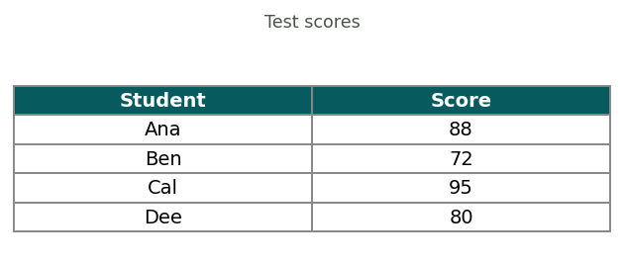
A. Ana
B. Ben
C. Cal
D. Dee
7. An axis is labeled 0, 25, 50, 75 with one line between each pair. What is each small line worth?
A. 5
B. 12.5
C. 25
D. 50
8. A question asks for the CHANGE in temperature from 40° on Monday to 65° on Friday. What is the change?
A. 25 degrees
B. 40 degrees
C. 65 degrees
D. 105 degrees
9. In a pie chart, which slice shows the largest part of the whole?
A. The smallest slice
B. The biggest slice
C. The top slice
D. They are all equal
10. Before reading the numbers on any graph, what should you check first?
A. The color of the bars
B. The title, axis labels, and units
C. The size of the paper
D. The last data point
11. Which class collected the FEWEST cans?
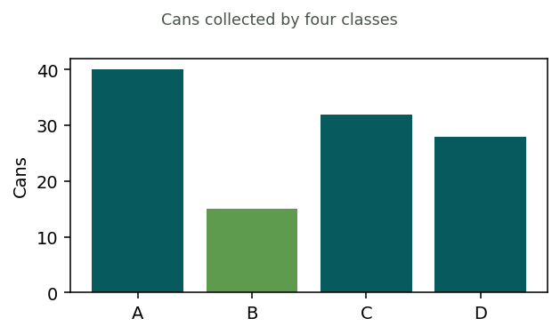
A. Class A
B. Class B
C. Class C
D. Class D
12. On a line graph, a flat (horizontal) section means:
A. The value is rising fast
B. The value is falling
C. No change during that time
D. The graph is broken
13. On a pie chart, a slice that fills about half the circle represents about:
A. 10%
B. 25%
C. 50%
D. 90%

Basic Math Reminders
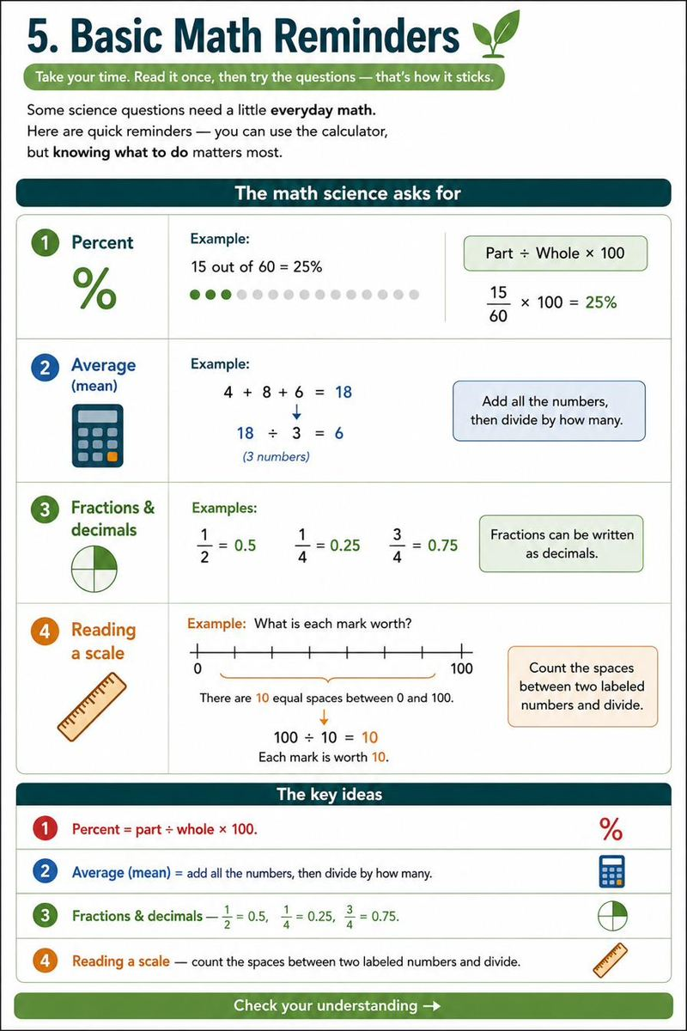
Questions
1. What is 25 out of 50 written as a percent?
A. 10%
B. 25%
C. 50%
D. 75%
2. What is the average (mean) of 10, 20, and 30?
A. 10
B. 20
C. 30
D. 60
3. What is 1/4 written as a decimal?
A. 0.14
B. 0.25
C. 0.40
D. 0.50
4. What is 10% of 200?
A. 2
B. 10
C. 20
D. 100
5. Round 68 to the nearest ten.
A. 60
B. 65
C. 70
D. 80

