Life Science Study Book
Diagrams & Practice Questions — Student Edition
GED & HiSET Science · GRDM Publishing, LLC · gingertheteacher.com
Study the diagram, then circle the best answer for each question.
Name: _______________________________ Date: ______________

Cells & Cell Processes
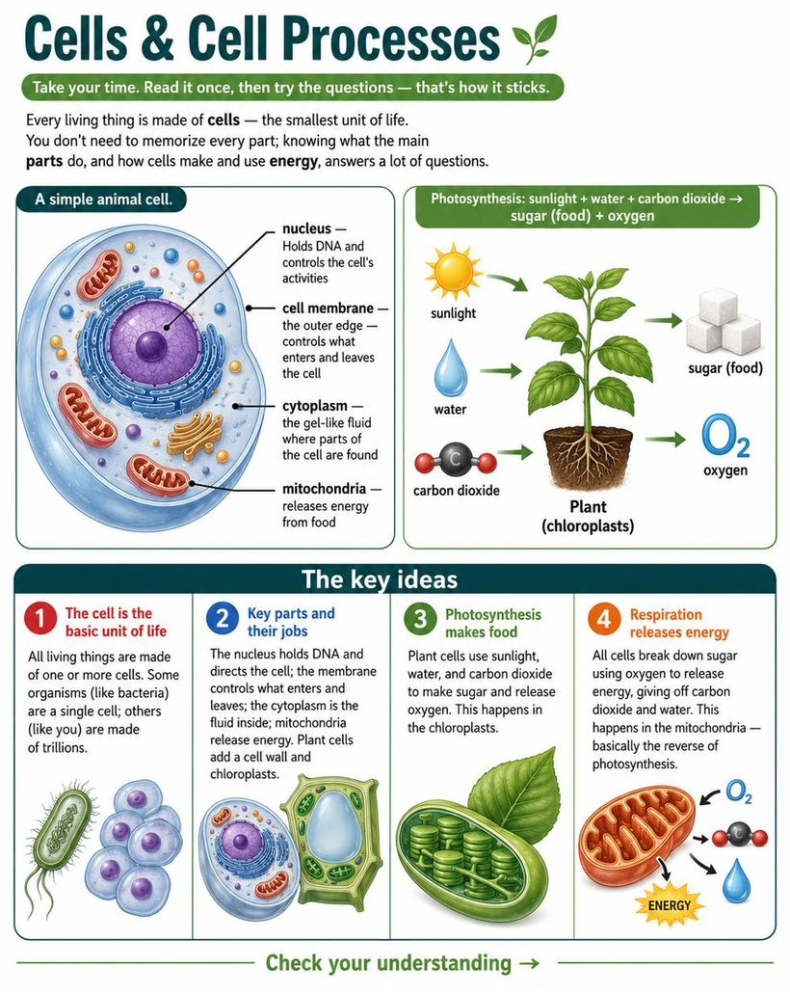
Questions
1. How does the body make new cells to heal a cut?
A. Cells appear from nothing
B. Existing cells divide in two
C. The heart makes them
D. Food turns straight into cells
2. Which biomolecule is mainly used to BUILD and REPAIR the body?
A. Carbohydrates
B. Proteins
C. Fats
D. Water
3. Which part of a cell contains its DNA and directs its activities?
A. Cell membrane
B. Nucleus
C. Cytoplasm
D. Cell wall
4. Green plants make food from sunlight, water, and carbon dioxide. This process is:
A. Respiration
B. Digestion
C. Photosynthesis
D. Evaporation

Human Body Systems
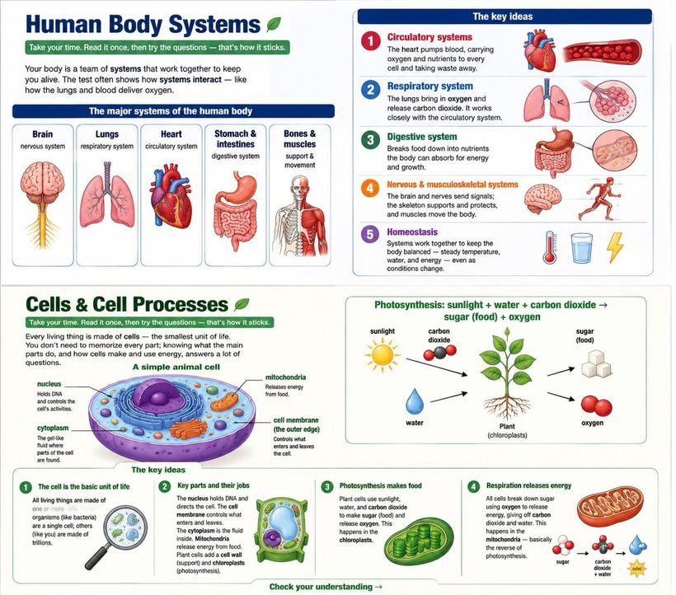
Questions
1. What is the main idea of this passage?
A. The heart is the most important organ
B. The body's systems each have a job and work together to keep it alive
C. Blood carries oxygen
D. Bones support the body
2. In the passage, keeping the body balanced and alive is called:
A. Digestion
B. Homeostasis
C. Respiration
D. Circulation
3. Which of the following is NOT a job of the skeletal system?
A. Supporting the body
B. Protecting organs
C. Pumping blood
D. Working with muscles to move
4. Which two systems work together to get oxygen into the blood?
A. Digestive and nervous
B. Respiratory and circulatory
C. Skeletal and muscular
D. Digestive and circulatory

Genetics & Heredity
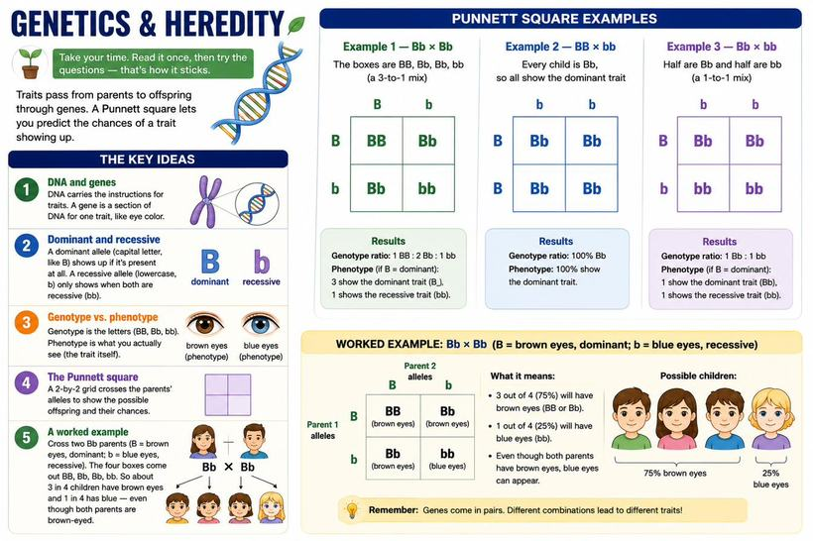
Questions
1. In a Bb × Bb cross, what percent of the offspring are expected to show the RECESSIVE trait?
A. 0%
B. 25%
C. 50%
D. 75%
2. Inside the nucleus, DNA is packed into structures called:
A. Chromosomes
B. Mitochondria
C. Membranes
D. Ribosomes
3. If both parents are Bb, what fraction of offspring are expected to be bb?
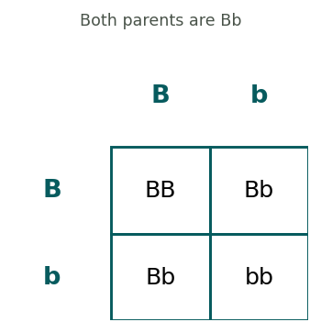
A. 1/4
B. 1/2
C. 3/4
D. 0
4. What fraction of the offspring are expected to be tall (have at least one T)?
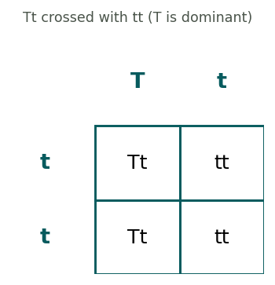
A. 1/4
B. 1/2
C. 3/4
D. All
5. An allele that shows up only when two copies are present is called:
A. Dominant
B. Recessive
C. A phenotype
D. A gene
6. In this BB × bb cross, what genotype will ALL of the offspring have?
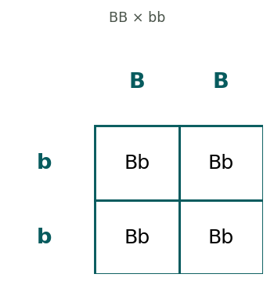
A. BB
B. Bb
C. bb
D. A mix of all three
7. In a Bb × Bb cross, what is the genotype ratio of the offspring?
A. 1 BB : 2 Bb : 1 bb
B. All Bb
C. 1 BB : 1 bb
D. 3 BB : 1 bb
8. B (brown eyes) is dominant over b (blue eyes). In a Bb × Bb cross, what fraction of children are expected to have BROWN eyes?
A. 1/4
B. 1/2
C. 3/4
D. All
9. In this Bb × bb cross, what fraction of the offspring are bb?
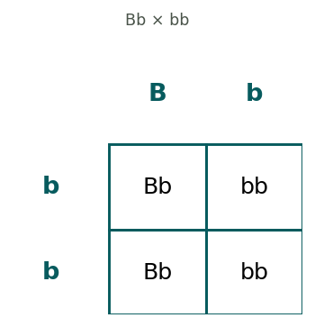
A. 1/4
B. 1/2
C. 3/4
D. 0
10. A person who carries one recessive allele hidden behind a dominant one (like Bb) is called a:
A. Twin
B. Carrier
C. Clone
D. Donor
11. Which of these describes a PHENOTYPE rather than a genotype?
A. Bb
B. BB
C. Brown eyes
D. bb

Evolution & Natural Selection
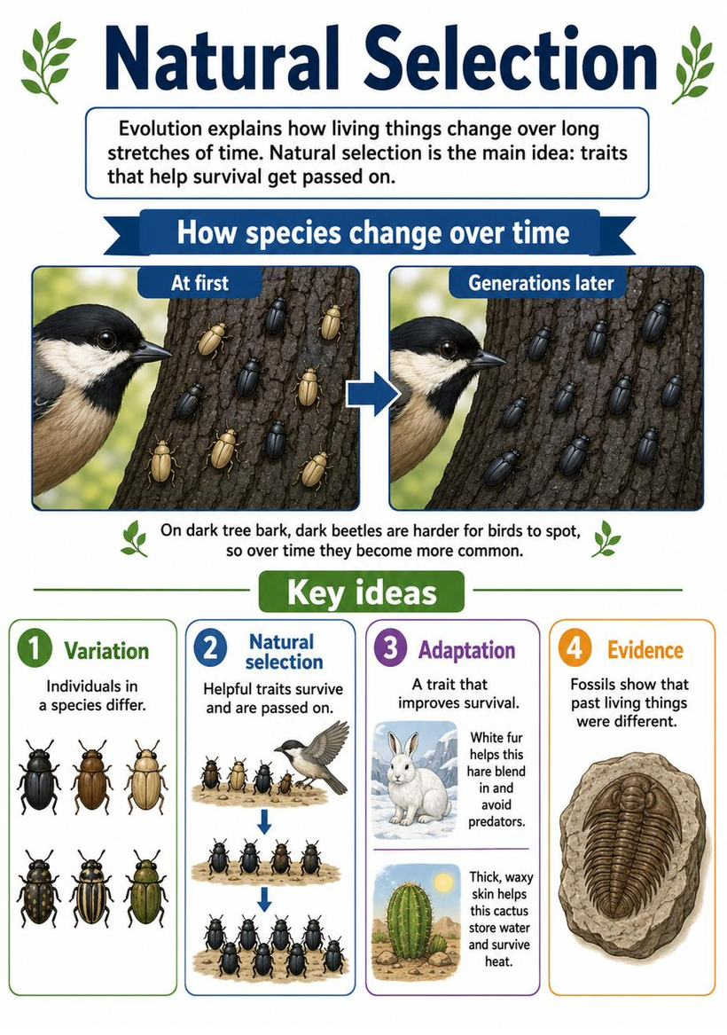
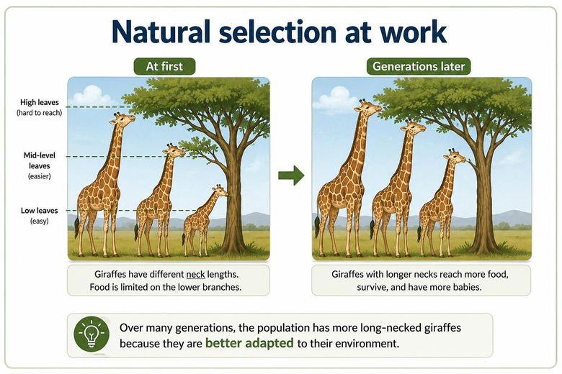
Questions
1. In a dark forest, dark moths are hidden from birds while light moths get eaten. Over time, most moths become dark. This is an example of:
A. Photosynthesis
B. Natural selection
C. Homeostasis
D. Erosion
2. A trait that helps an organism survive in its environment is called:
A. A mutation
B. An adaptation
C. A phenotype
D. A control

Ecosystems & Energy Flow
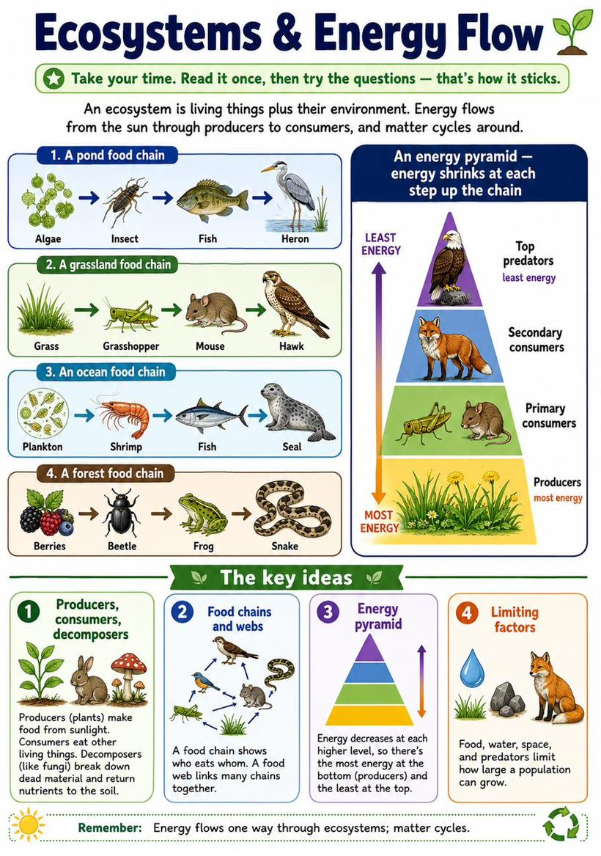
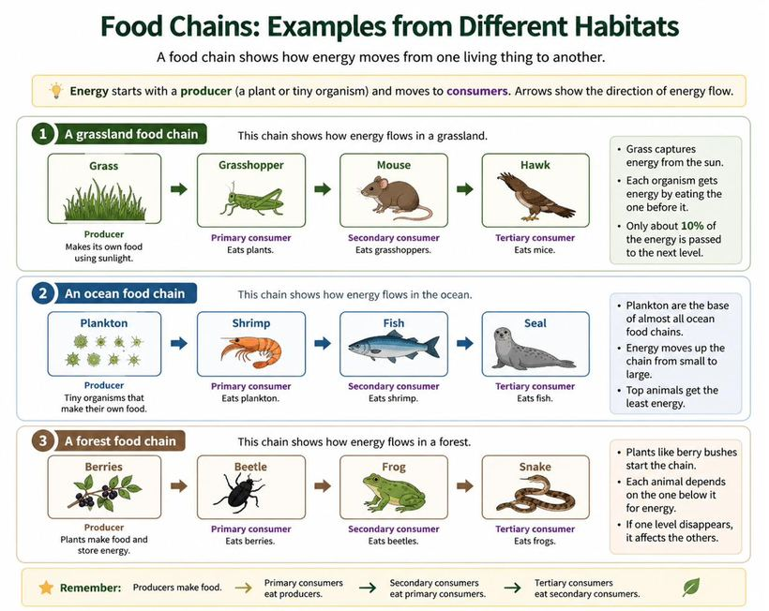
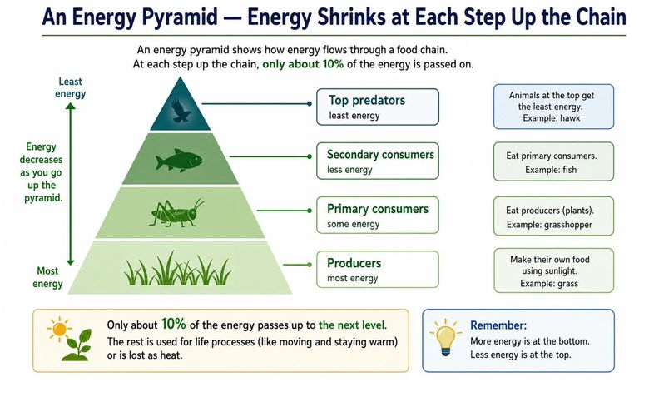
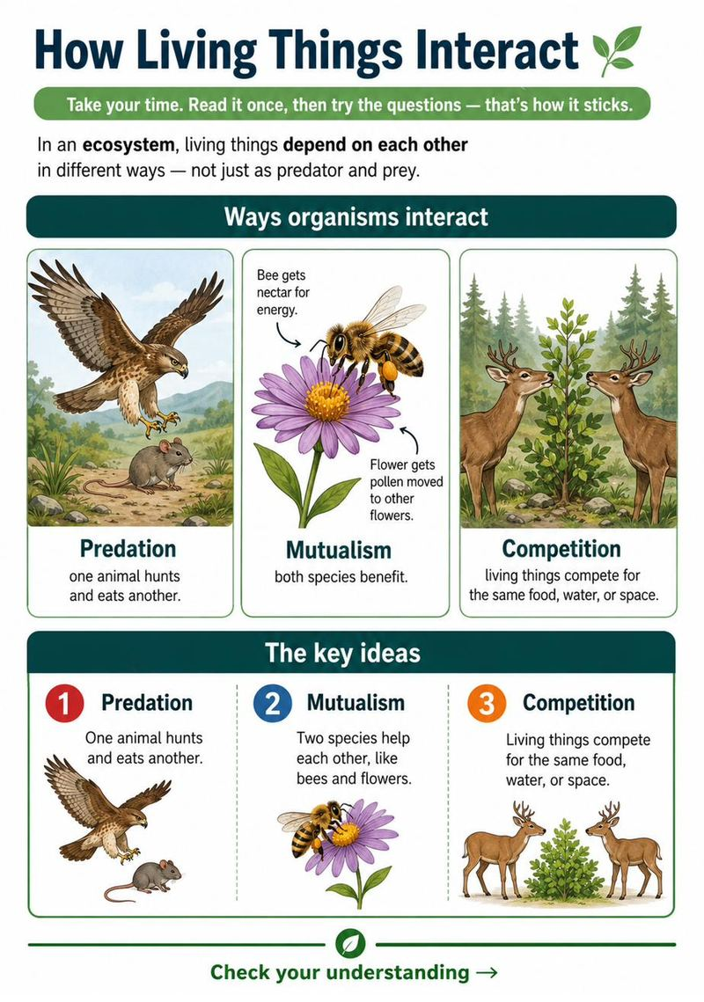
Questions
1. The largest population an ecosystem can support over time is called its:
A. Food web
B. Carrying capacity
C. Energy pyramid
D. Habitat
2. Bees and flowers helping each other is an example of:
A. Predation
B. Mutualism
C. Competition
D. Erosion
3. Two deer feeding from the same small patch of grass are in:
A. Mutualism
B. Predation
C. Competition
D. Cooperation
4. What is the main idea of this passage?
A. Plants are green
B. How energy and matter move through an ecosystem
C. Predators are dangerous
D. Soil is important
5. Based on the passage, why are there fewer top predators than plants?
A. Predators are bigger
B. Energy shrinks at each step of the chain
C. Plants reproduce quickly
D. There is a rule against predators
6. In this food chain, which organism is the primary consumer?
Algae → Insect → Fish → Heron
A. Algae
B. Insect
C. Fish
D. Heron
7. Which level of the food chain has the most available energy?
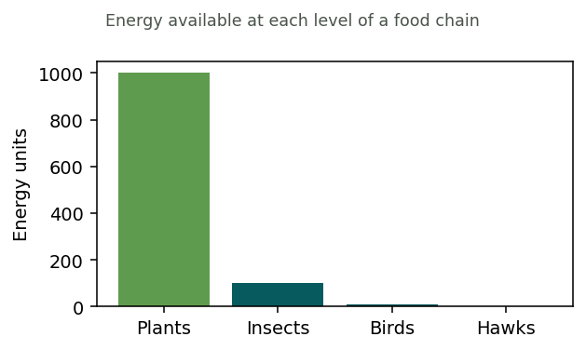
A. Plants
B. Insects
C. Birds
D. Hawks
8. What is the main role of decomposers in an ecosystem?
A. To make food from sunlight
B. To break down dead material and recycle nutrients
C. To hunt large animals
D. To produce oxygen
9. In this grassland food chain, which organism is the producer?
Grass → Grasshopper → Mouse → Hawk
A. Grass
B. Grasshopper
C. Mouse
D. Hawk
10. Which organism is the primary consumer — the first to eat the producer?
Grass → Grasshopper → Mouse → Hawk
A. Grass
B. Grasshopper
C. Mouse
D. Hawk
11. In this ocean food chain, which organism is the top predator?
Plankton → Shrimp → Fish → Seal
A. Plankton
B. Shrimp
C. Fish
D. Seal
12. Which organism is a secondary consumer — it eats the primary consumer?
Plankton → Shrimp → Fish → Seal
A. Plankton
B. Shrimp
C. Fish
D. Seal
13. If the beetles disappeared from this food chain, what would most likely happen to the frogs?
Berries → Beetle → Frog → Snake
A. They would have more food
B. They would have less food
C. Nothing would change
D. They would become producers

Reading an Article: How Vaccines Work
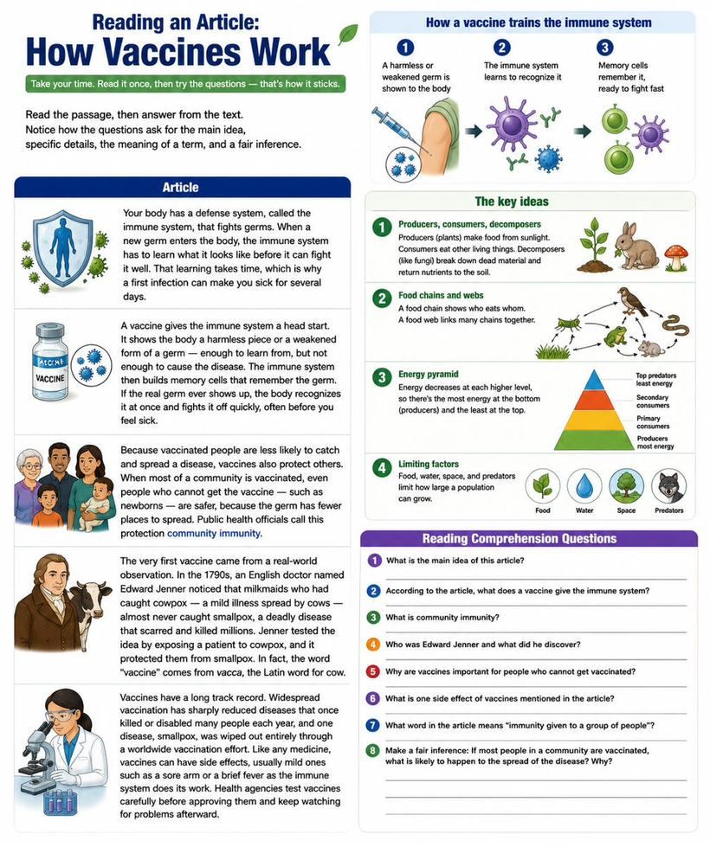
Questions
1. What is the main idea of the passage?
A. The immune system is slow
B. How vaccines help the body fight disease
C. Newborns get sick easily
D. Germs are everywhere
2. According to the passage, what does a vaccine show the body?
A. A strong, full-strength germ
B. A harmless piece or weakened form of a germ
C. A memory cell
D. A dose of medicine
3. In the passage, 'memory cells' are cells that:
A. Store your thoughts
B. Remember a germ so the body can fight it faster later
C. Make you feel sick
D. Replace the vaccine
4. Why can a first infection make you sick for several days?
A. The germ is stronger the first time
B. The immune system needs time to learn the new germ
C. Vaccines wear off
D. Memory cells attack the body
5. 'Community immunity' most helps people who:
A. Are already vaccinated
B. Cannot get the vaccine, such as newborns
C. Never leave home
D. Make vaccines
6. According to the passage, how did Edward Jenner get the idea for the first vaccine?
A. He read about it in a book
B. He noticed milkmaids who had cowpox rarely caught smallpox
C. He invented it in a lab
D. He caught smallpox himself

Reading an Article: Why Bees Matter
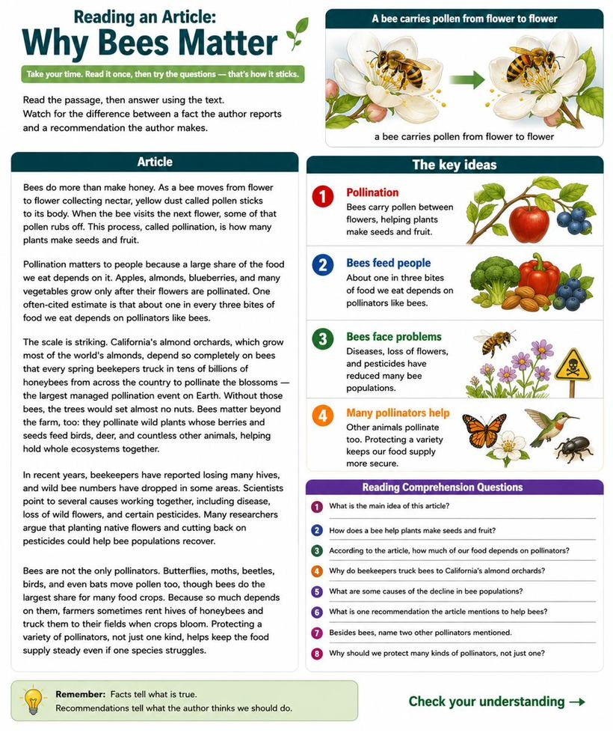
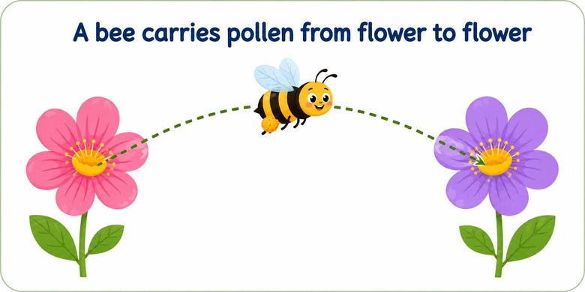
Questions
1. What is the main idea of the passage?
A. Bees make honey
B. Bees are important pollinators, and their numbers are dropping
C. Flowers need nectar
D. Pesticides are useful
2. According to the passage, what is pollination?
A. Bees making honey
B. Pollen moving from flower to flower so plants make seeds and fruit
C. Flowers producing nectar
D. Bees losing their hives
3. Based on the passage, if bees disappeared, we would most likely expect:
A. More honey
B. Less of foods like apples and almonds
C. More wild flowers
D. Fewer pesticides
4. The passage uses 'about one in every three bites of food' to show:
A. How much honey bees make
B. How much of our food depends on pollinators
C. How many bees exist
D. How fast bees fly
5. According to the passage, why are billions of honeybees trucked into California's almond orchards each spring?
A. To make honey for sale
B. Because the almond trees depend on bees to pollinate their blossoms
C. To protect the trees from pests
D. To collect water for the trees
6. Beyond farms, how else does the passage say bees are important?
A. They clean rivers
B. They pollinate wild plants that feed birds, deer, and other animals
C. They control the weather
D. They build the soil

Reading an Article: Cells, the Building Blocks of Life
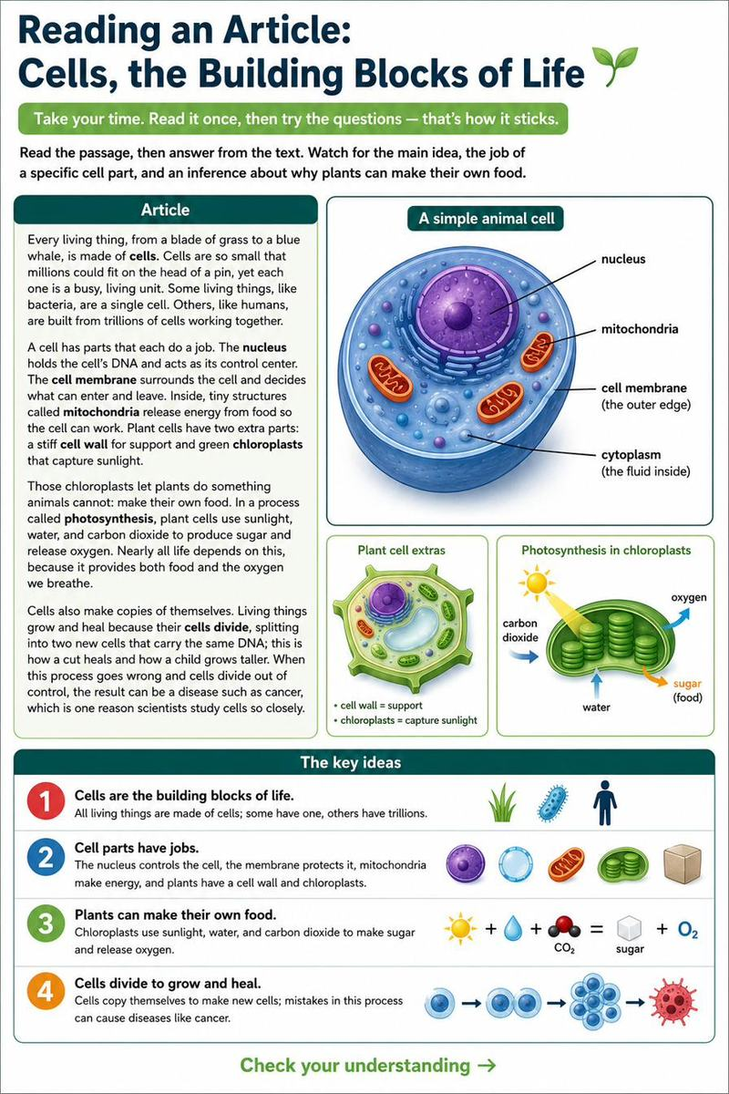
Questions
1. What is the main idea of the passage?
A. Bacteria are tiny
B. All living things are made of cells, which carry out life's jobs
C. Plants are green
D. Humans have trillions of cells
2. According to the passage, what is the job of the nucleus?
A. To release energy
B. To hold the DNA and control the cell
C. To let things in and out
D. To capture sunlight
3. In the passage, 'photosynthesis' is the process by which:
A. Cells release energy from food
B. Plants make food from sunlight, water, and carbon dioxide
C. DNA is copied
D. Water enters the cell
4. Based on the passage, plants can make their own food but animals cannot because plants have:
A. A nucleus
B. Mitochondria
C. Chloroplasts
D. A cell membrane

Reading an Article: How the Body Uses Food
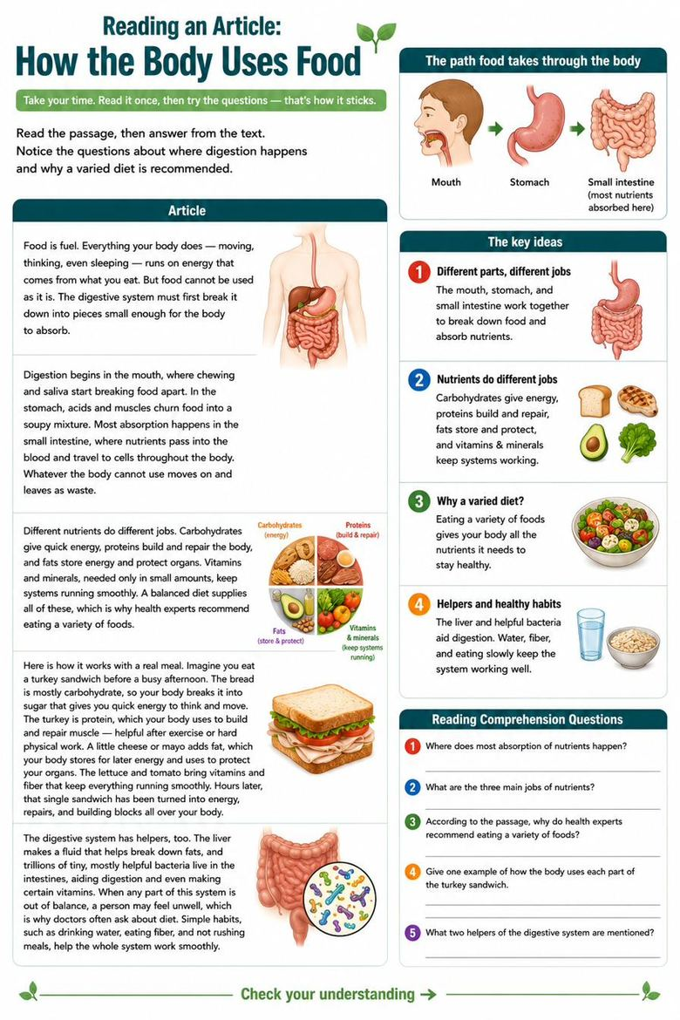
Questions
1. What is the main idea of the passage?
A. Chewing is important
B. How the body breaks down food and uses its nutrients
C. The stomach has acids
D. Waste leaves the body
2. According to the passage, where does most absorption of nutrients happen?
A. The mouth
B. The stomach
C. The small intestine
D. The blood
3. According to the passage, which nutrient mainly builds and repairs the body?
A. Carbohydrates
B. Proteins
C. Fats
D. Vitamins
4. Based on the passage, why do health experts recommend eating a variety of foods?
A. Variety tastes better
B. Different nutrients do different jobs the body needs
C. It is cheaper
D. It speeds up digestion
5. According to the passage, digestion begins in the:
A. Stomach
B. Small intestine
C. Mouth
D. Blood
6. You eat a bowl of oatmeal before a long walk. Which type of nutrient in the oatmeal gives you quick energy?
A. Protein
B. Carbohydrates
C. Fat
D. Water
7. After lifting weights, an athlete eats eggs and chicken. Which nutrient in that food mainly helps build and repair muscle?
A. Fat
B. Protein
C. Sugar
D. Vitamins

Reading an Article: Genes and Heredity
Questions
1. What is the main idea of the passage?
A. Everyone has DNA
B. How traits are passed from parents to children through genes
C. Blue eyes are rare
D. Punnett squares are hard
2. According to the passage, traits are carried in a molecule called:
A. Protein
B. DNA
C. An allele
D. A Punnett square
3. In the passage, a 'dominant' allele is one that:
A. Only shows with two copies
B. Shows up whenever it is present
C. Never shows up
D. Is carried only by fathers
4. Based on the passage, two brown-eyed parents can have a blue-eyed child because:
A. Blue eyes are dominant
B. Each parent carried a hidden recessive allele for blue eyes
C. The child has no genes from them
D. Eye color is random

Reading an Article: Natural Selection
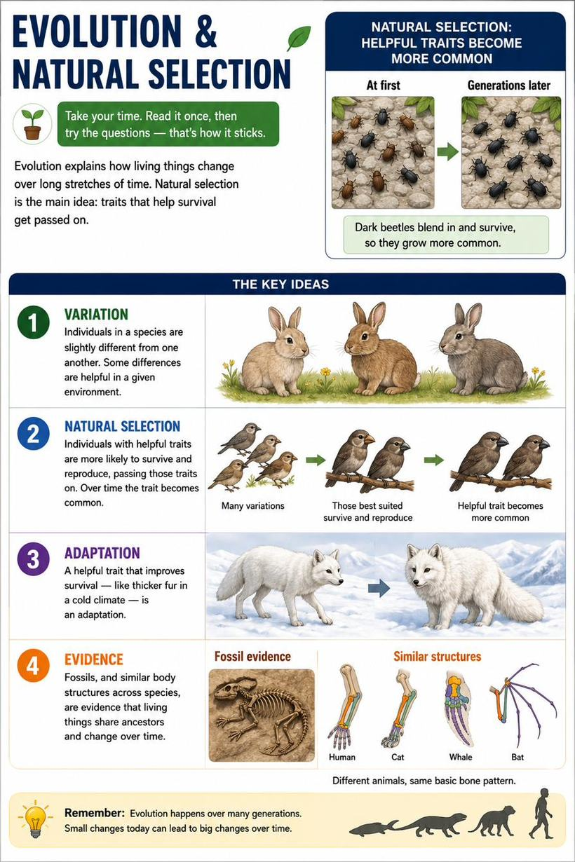
Questions
1. What is the main idea of the passage?
A. Beetles are dark
B. How species change over time through natural selection
C. Birds eat beetles
D. Fossils are old
2. In the passage, 'variations' are:
A. Types of birds
B. Small differences among individuals of a species
C. Changes in the weather
D. Kinds of trees
3. Based on the passage, why did the beetle group become mostly dark over time?
A. Dark beetles laid more eggs by chance
B. Birds ate the easy-to-see light beetles, so dark ones survived and reproduced
C. The bark turned dark
D. Dark beetles were larger
4. In the passage, a trait that improves survival in an environment is called:
A. A variation
B. An adaptation
C. A fossil
D. A species

